Accurate prediction of zinc ion location using deep learning

[ORCID icon](https://orcid.org/0000-0002-4304-8106) Simon L. Dürr 1, [ORCID icon](https://orcid.org/0000-0003-1255-859X) Andrea Levy 1, [ORCID icon](https://orcid.org/0000-0002-1704-8591) Ursula Röthlisberger 1,†

† — To whom correspondence should be addressed: ursula.roethlisberger@epfl.ch

###### Affiliations

1. Laboratory of Computational Chemistry and Biochemistry, Institute of Chemical Sciences and Engineering, Swiss Federal Institute of Technology (EPFL) CH-1015 Lausanne, Switzerland

## Abstract

Metal ions are an essential cofactor for many proteins. Currently, about half of the structurally characterized proteins contain a metal ion. Metals are an attractive cofactor for many applications such as enzyme design or design of protein-protein interactions because they are biologically abundant, tether to the protein using strong interactions, and have favorable catalytic properties e.g as lewis acid. Computational design of metalloproteins is hampered by the complex electronic structure of many biologically relevant metals such as zinc that cannot be accurately described using a classical forcefield. In this work, we develop two tools - Metal1D (based on distances) and Metal3D (based on 3D convolutional neural networks) to improve the identification and localization of metal ions in proteins. Metal3D is the most accurate metal ion location predictor to date, needs just a single structure as input and outputs a confidence metric for each predicted site. Even though the model was trained on zinc it has similar recall for other transition metals. The predicted metal ion locations for Metal3D are within 0.7 ± 0.6 Å of the experimental locations with half of the sites below 0.5 Å. The model predicts a global metal density that can be used for annotation of structures predicted using AlphaFold and a per residue metal density that can be used in protein design workflows for rotamer sampling to create novel metalloproteins.

## Introduction

Metalloproteins are ubiquitous in nature and are present in all major enzyme families.1,2 The metals typically found in biological systems are the first and second row alkali and earth alkali metals and the first row transition metals such as zinc and copper. Zinc is the most common transition metal (present in ~10% of deposited structures) and can fulfill both a structural role (e.g in Zinc finger proteins) or a catalytic role in up to trinuclear active sites. Zn2+ is an excellent Lewis acid and is most often found in tetrahedral, pentavalent or octahedral coordination. About 10 % of all reactions catalyzed by enzymes use zinc as cofactor.3

Metalloproteins are well studied because metal cofactors are essential for the function of many proteins. Loss of this function is an important cause of diseases.4 Industrial applications for metalloproteins result from the favorable catalytic properties of the metal ion with the tunable protein environment dictating (stereo)-selectivity.5,6 To crystallize proteins, metal salts are also often added to the crystallization buffer as they can help in the formation of protein crystals overcoming the enthalpic cost of association of protein surfaces. Metal ion binding sites can be used to rapidly engineer protein-protein interactions (PPI)9–11 and the hypothesis has been put forward that one origin of macromolecular complexity is the superficial binding of metal ions in early single domain proteins.11 Many metal ion binding sites are still found at interfaces in modern proteins.

While simple metal ion binding sites can be rapidly engineered because initial coordination on a protein surface can for example be achieved by creating an i, i+4 di-histidine site12 or by placing cysteines in spatial proximity,13 the engineering of complex metal ion binding sites is considerably more difficult2,10 as such sites are often supported by a network of hydrogen bonds. A complication for computational design of metalloproteins is the unavailability of good non-bonded force fields for zinc and other transition metals that accurately reproduce tetrahedral coordination with the correct coordination distances which renders design e.g using Rosetta very difficult.2,14 The latest parametrization of the Rosetta energy function (ref2015)15 did not refit the parameters for the metal ions which originally are from CHARMM27 with the Lazaridis-Karplus solvation terms being a wild guess [sic]. To treat metal sites in proteins adequately quantum mechanical treatment such as in hybrid quantum mechanics/molecular mechanics (QM/MM) simulations16,17 is needed whose computational cost is prohibitive for regular protein design tasks. QM/MM simulations can however be used to verify coordination chemistry for select candidate proteins.18 Neural network potentials have been developed for zinc however those require the experimental zinc location as input.19

Many tools exists to predict whether a protein contains metals (e.g ZincFinder20), which residues in the protein bind a metal (e.g IonCom,21 MIB22) and where the metal is bound (AlphaFill,23 FindsiteMetal,24 BioMetAll,25MIB22 ). The input for these predictors is based on sequence and/or structure. Sequence-based predictors use pattern recognition to identify the amino acids which might bind a metal.26 On the other hand, structure-based methods are based on the 3D structure, either using homology to known structures (MIB, Findsite-metal, AlphaFill) or distance features (BioMetAll) to infer the location of metals. Some tools like Findsite-metal or ZincFinder employ classical machine learning based approaches such as support vector machines.

Structure based deep learning approaches have been used in the field of protein research for a variety of applications such as protein structure prediction,27 prediction of identity of masked residues29–31), functional site prediction,32,33 for ranking of docking poses,34,35 prediction of the location of complex organic ligands,35–38 and prediction of effects of mutations for stability and disease.4 Most of those methods represent the protein as voxels and apply 3D convolutional neural networks (3DCNN). Other architectures that treat the protein as surfaces or graphs often are constrained to use coarse grained sidechain information due to the computational cost.

Current state of the art predictors for metal location are MIB,22,40 which combines structural and sequence information in the “Fragment Transformation Method” to search for homologous sites in its database, and BioMetAll,25 a geometrical predictor based on backbone preorganization. Both methods have significant drawbacks: MIB excluded metal sites with less than 2 coordination partners from its analysis and is limited by the availability of templates in its databank. BioMetAll does not use templates but provides many possible locations for putative binding sites on a regular grid. The individual probes in BioMetAll do not have a confidence metric therefore only allowing to rank sites by the number of probes found which results in a large uncertainity in the position. Both tools suffer from many false positives. In this work, we present two metal ion location predictors that do not suffer from these drawbacks. The deep learning based Metal3D predictor operates on a voxelized representation of a protein environment and predicts a per residue metal density that can be averaged to get a smooth metal probability density over the whole protein. The distance based predictor Metal1D predicts the location of metals using distances mined from the protein databank predicting coordinates directly. These tools pave the way to perform in silico design of metal ion binding sites without relying on predefined geometrical rules or expensive quantum mechanical calculations. This will allow to exploit the catalytic diversity of metal ions to design enzymes for new-to-nature reactivities more easily.

## Materials and Methods

### Dataset

The input PDB files for training were obtained from the RCSB41 protein databank (downloaded 5th March 2021). We used a clustering of the structures at 30% sequence identity using mmseqs242 as the input to largely remove sequence and structural redundancy in the input dataset. For each cluster we check whether a zinc is contained in one of the structures, whether the resolution of these structures is better than 2.5 Å, if the experimental method is x-ray crystallography and whether the structure does not contain nucleic acids. If there are multiple structures fulfilling these criteria the highest resolution structure is used. All structures larger than 3000 residues are discarded. We always use the first biological assembly to sample the training environments as metals are often located at protein interfaces. All structures are filtered to only contain zinc and protein residues. If there are multiple models in the structure the first one is used. For each biological assembly we used the symmetry of the assymetric unit to generate a protein structure that contains all neighboring copies of the protein in the crystal such that metal sites at crystal contacts are fully coordinated.

The train/val/test split was performed based on sequence identity using easy-search in mmseqs2. All proteins that had no (partial) sequence overlap with any other protein in the dataset were put into the test/val set (85 proteins) which we further split into a test set of 55 structures and a validation set of 25 structures. The training set contained 2085 structures. (Supplemental Data 1).

For the analysis, we always used the biological assembly and not the symmetry augmented structure. For the selectivity analysis, the clusters from the PDB were randomly sampled to extract about 25 biological assemblies per metal (Supplemental Data 2) and all metal sites that had at minimum 3 unique protein ligands within 2.8 Å of the metal were used for the analysis to exclude any crystallization artefacts for the selectivity analysis. For the zinc analysis we used either all zinc ions contained in the structures or all that had at minimum 2 unique protein ligands within 2.8 Å of the metal. This removes most sites that are crystal contacts.

### Metal 1D

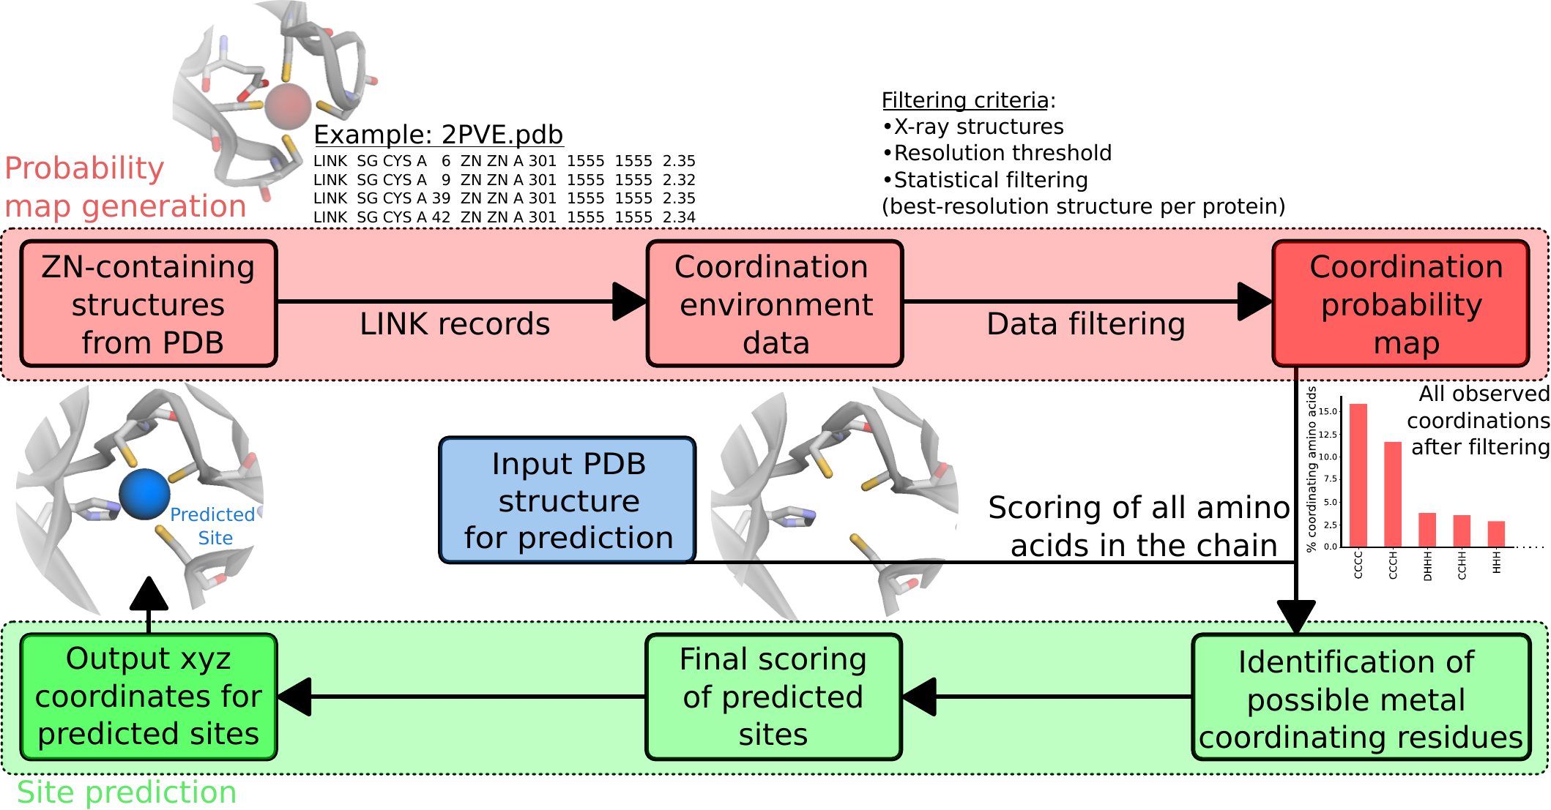

Figure 1: Workflow of Metal1D

Metal1D uses a probability map derived from LINK records in protein structures. The LINK section of a PDB file specifies the connectivity between zinc (or any other metal ion) and the amino acids of the protein, and each LINK record specifies one linkage. The idea of basing this approach on the LINKs is an extension to the approach by Barber-Zucker *et al.*,43 where they used the LINK records to investigate the propensity of transition metals to bind different amino acids, but not for the coordination.

Using the training set we generated a probability map for the propensity of different coordination environments to bind a zinc (e.g CCCC, CCHH etc.). For each zinc ion the coordination is extracted from theLINK records excluding records involving only single amino acids (weak binding sites). Also, LINK records containing water molecules are excluded because of the difficulties in placing water molecules a posteriori in 3D structures when metal ions are present and because data quality of modelled water molecules varies. The probability map contains the counts of coordination environments found.   
To make a prediction, each amino acid of a protein is scored (Figure 1). The procedure has two steps: Identification of possible metal coordinating residues in the structure and scoring of the likelihood of the coordination after a metal has been placed between the identified coordinating residues.

The protein structure is analyzed using the BioPandas python library.44 To identify coordinating residues a per residue score is assigned performing a geometrical search from a reference point, defined as the coordinate of the most probable metal binding atom, within a search radius, considered as twice the typical distance between the metal ion and the binding atom of amino acids in proteins (2.2 ± 0.2 Å as determined from LINK records). The search radius used was 5.5 Å in order to be able to take into account deviations from the ideal coordination. In the case of amino acids which present more than one atom which typically binds metals, such as histidine, the mid-point is used as reference point and the search radius is enlarged accordingly. The atoms used as reference points for each amino acid and the increase in the search radius are reported in Supplemental Table 1 . The score is assigned to each amino acid considering all the other reference points of other amino acids within the search radius, and summing the probabilities in the probability map for coordinations compatible with the one observed. In the ideal case, a score of 1 corresponds to an amino acid surrounded by all possible coordinating amino acids observed in the probability map. In practice, scores result between 0 and less than 1. Once all amino acids in the chain are scored,the metal location predictions are made grouping the highest-scored amino acids in clusters (defined as the ones within the chosen threshold with respect to the highest-scored one), based on distance. This is done using the scipy.spatial.distance_matrix and grouping together highest-scored amino acid closer than twice the search radius. For each cluster, a site prediction is made as a weighted average between the coordinates of the reference point of each amino acid, using as weighting factor the amino acid score. For isolated amino acids with a high score (e.g a single histidine) the same score is assigned to the closest reference point from another amino acid, to be able to compute the position of the metal as before. Possible artefacts resulting from this fictitious score are resolved in the final step of the prediction.

After the metal has been placed the likelihood of the putative sites can be assessed by performing a geometrical search centered on the predicted metal coordinates (within 60% of the search radius, i.e. 3.3 Å) and a final score is now assigned to the site. The final score is assigned in the same way as the amino acid scores, based on the probability map, and has the advantage of being able to sort the predicted metal sites based on their frequency in the training set. A cutoff parameter is used to exclude site with a probability lower than a certain threshold with respect to the highest-scored one. This final scoring also mitigates the errors which can be introduced by calculating the coordinates of the site simply as a weighted average, excluding or assigining a low probability to the site ending in unfavorable positions in space.

### Metal 3D

#### Voxelization

We used the moleculekit python library37,45 to voxelize the input structures into 3D grids. 8 different input channels are used: aromatic, hydrophobic, positive ionizable, negative ionizable, hbond donor, hbond acceptor, occupancy and metal ion binding site chain. The channels are assigned using AutoDockVina atom names and a boolean mask. For each atom matching one of the categories a pair correlation function centered on the atom is used to assign the voxel value.37 For the target tensor only the zinc ions were used for the voxelization. The target tensor was discretized setting any voxel above 0.05 to 1 (true location of zinc), all other to 0 (no zinc). We used a box size of 16 Å centered on the Cɑ atom of a residue, rotating each environment randomly for training before voxelization. The voxel grid used a 0.5 Å resolution for the input and target tensors. Any alternative sidechain conformations modeled were discarded keeping only the highest occupancy. For the voxelization only heavy atoms were used. For all structures selected for the respective sets we partitioned the residues of the protein into residues within 12 Å of a zinc ion and ones not within 12 Å of a zinc (based on distance to the Cɑ atom). A single zinc site will therefore be present many times in the dataset but each time translated and rotated in the box. A balanced set of examples was used sampling an equal amounts of residues that are close to a zinc and residues randomly drawn from the non-zinc binding residues. The sampling of residues is based on the biological assembly of the protein, the voxelization is based on the full structure including the neighboring assymetric units in the crystal structure. The environments are precomputed and stored using lxf compression in HDF5 files for concurrent access during training (83 GB). In total 266283 environments were voxelized for the training set, 6550 for the test set, 3067 for the validation set. The voxelization was implemented using ray.46

#### Model training

We used PyTorch 1.1047 to train the model. All layers of the network are convolutional layers with filter size 3 Å except for the fifth layer where a 16 Å filter is used to capture long range interactions. We use zero padding to keep the size of the boxes constant. Models were trained on a workstation with NVIDIA GTX3090 GPU and 32 CPU cores. Binary Cross Entropy48 loss is used to train the model. The rectified linear unit (ReLU) non-linearity is used except for the last layer which uses a sigmoid function which yields the probability for zinc per voxel. A dropout layer (p = 0.2) was used between the 5th and 6th layers. The network was trained using AdaDelta employing a stepped learning rate (lr=1.0, ɣ=0.7), a batch size of 150, and 12 epochs to train.

#### Hyperparameter tuning

We used the ray[tune] library46 to perform a hyperparameter search choosing 20 different combinations between the following parameters:

* filtersize: 3,4
* dropout : 0.1, 0.2, 0.4, 0.5
* learning rate : 0.5, 1.0, 2.0
* gamma: 0.5, 0.7, 0.8, 0.9
* largest dimension 80, 100, 120

#### Grid Averaging

The model takes as input a (8,32,32,32) tensor and outputs a (1,32,32,32) tensor containing the probability density for zinc centered on the Cɑ atom of the input residue. Predictions for a complete protein were obtained by voxelizing select residues of the protein (default all cysteines, histidines, aspartates, glutamates) and averaging the boxes using a global grid (Figure 2). The global grid is obtained by computing the bounding box of all points and using a regular spaced (0.5 Å) grid. For each grid point in the global grid the predicted probability maps within 0.25 Å of the grid point are averaged. The search is sped up using the KD-Tree implementation in scipy.49

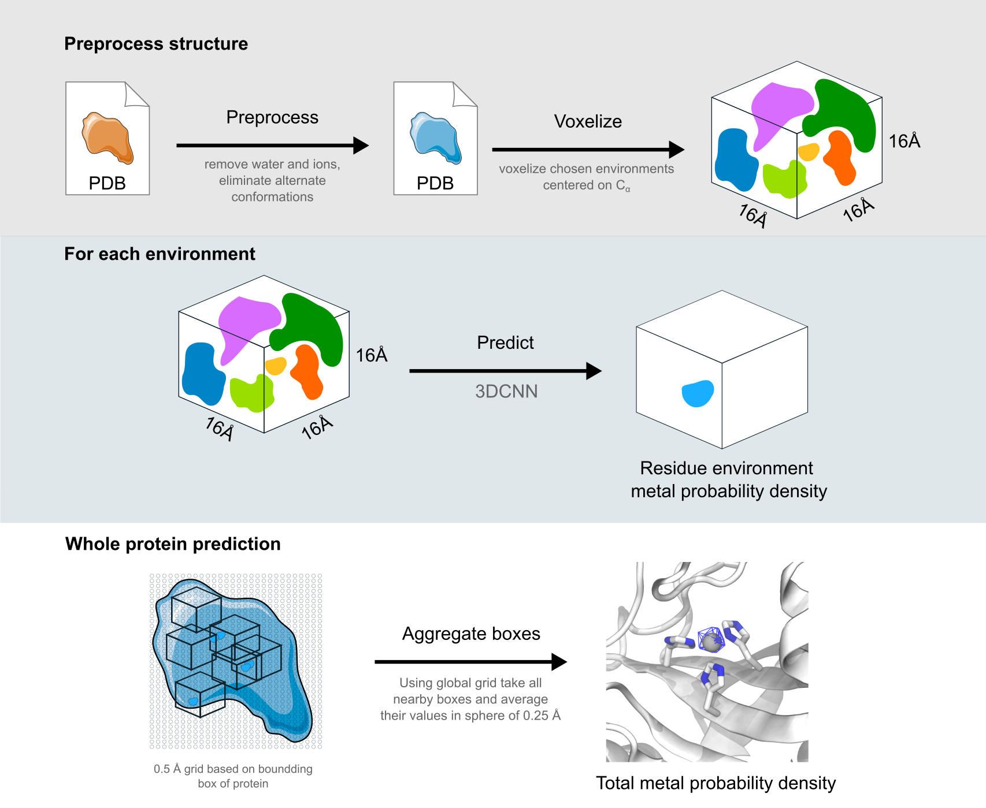

Figure 2: Workflow of Metal3D with preprocessing step to voxelize an environment, passing each environment seperately through the model, compute the bounding box of the protein and averaging the per residue metal probabilities to obtain a smooth probability density over the whole protein.

##### Metal ion placement

The global probablity map is used to perform clustering of points above a certain probability threshold (default p=0.5) using agglomerative clustering implemented in scikit-learn.50 For each cluster the weighted average of the voxels in the cluster is computed using the probabilities for each point as the weight. This results in one metal placed per cluster.

##### Visualization

We make available a command line program and interactive notebook allowing to visualize the results. The averaged probability map is stored as a cube file. The most likely coordinates of metals for use in subsequent processing is stored in a pdb file. The command line program uses VMD51 to visualize the input protein and the predicted density, for the jupyter notebook 3Dmol.js/py3Dmol52 is used.

#### Evaluation

##### Comparison

In order to standardize the evaluation between different tools, we always used the same test set used for the training of Metal1D and Metal3D. In order to compute standard metrics such as precision and recall we chose to assess performance of all assessed tools (Metal1D, Metal3D, BioMetAll, MIB) in a binary fashion. Any prediction within 5 Å of an experimental metal site is counted as true positive (TP). Multiple predictions by the same tool for the same site are counted as 1 TP. Any experimental site that has no predicted metal within 5 Å is counted as false negative (FN). A false positive (FP) prediction is a prediction that is not within 5 Å of a zinc site and also not within 5 Å of any other false positive prediction. If two or more false positive predictions are within 5 Å, they are counted as a single false positive prediction for the same site. In practice we first evaluate the true positive and false negative predictions and remove those from the set of predicted positions. The remaining predictions are all false positives and are clustered using AgglomerativeClustering with a radius of 5 Å. The number of false positives is determined from the number of clusters. Using the binary metric we assed how good the models are at discovering sites and how much these predictions can be trusted.

In order to assess the quality of the predictions, we additionally compute for all the true positive predictions the mean of the euclidean distance between the true and predicted site (mean absolute deviation MAD). For Metal1D, MIB, and BioMetAll, MAD was computed for all predictions above the threshold within 5 Å of a true zinc where $∑\text{predicted sites}≥∑\text{ TP}$. This was done as some tools predict the same site for different residue combinations and we wanted to assess the general performance for all predicted sites above a certain cutoff and not just for the best predicted site above the cutoff. For Metal3D the weighted average of all voxels above the cutoff was used.

Precision was calculated as

$$\text{Precision}=\frac{\#\text{ correct metal sites}}{\#\text{ correct metal sites}+\#\text{ false positive clustered}}=\frac{\text{TP}}{\text{TP}+\text{FP}}$$

Recall was calculated as

$$\text{Recall}=\frac{\#\text{ correct metal sites}}{\#\text{ correct metal sites}+\#\text{ not found metal sites}}=\frac{\text{TP}}{\text{TP}+\text{FN}}$$

##### Model assessment Metal3D

To evaluate the trained models we monitored loss and how accurately the model predicts the metal density of the test set. We used a discretized version of the Jaccard index setting each voxel either as 0 (no metal) or 1 (zinc present). We tested multiple different decision boundaries (0.5, 0.6, 0.75, 0.9) and also compared a slightly smaller centered box to remove any spurious density at the box edges, where the model has only incomplete information to make predictions.

The Jaccard index is computed as

$$J=\frac{\#\left|V_{p}∩V_{exp}\right|}{\#\left|V_{p}∪V_{exp}\right|},$$

where $Vp$ is the array of voxels with predicted probability above the decision boundary and $V_{exp}$ is the array of voxels with the true metal locations also discretized at the same probability threshold.

##### HCA2 mutants

The data for human carbonic anhydrase 2 (HCA2) mutants was extracted from refs53–57 and the crystal structure 2CBA58,59 was used. The zinc was modeled using the zinc cationic dummy model forcefield60 and we verified that energy minization produced the correct coordination environment. The Richardson rotamer library61 was used with the EVOLVE-ddG energy function to compute the most stable rotamer for a given mutation with the zinc present. The lowest-energy mutant was used for the prediction of the location of metals using Metal3D.

## Results

The dataset used for all training and analysis was obtained from the RCSB Protein Data Bank.41 We used the clustered PDB at 30% sequence identity to remove similar structures and used the highest resolution structure from each cluster that contained a zinc, did not contain DNA/RNA and had resolution < 2.5 Å. In case no structure was found the cluster was discarded for the training of the models.

### Metal1D

The statistical analysis for the distance based model uses the LINK records present in deposited PDB structures. These training set structures are used to generate a probability map for the coordinating amino acids. In inference mode, the map is used to predict metal sites: for a given protein structure, each amino acid of the protein is scored based on the probability map, performing a geometrical search around the amino acid. For zinc, the average LINK distance found in the training set was 2.2 ± 0.2 Å, and the default search radius was set to 5.5 Å.

Once all amino acids in the chain are scored, site predictions are made grouping the highest-scored amino acids in clusters, based on distance (using twice the search radius as cutoff). For each cluster, a site prediction is made as a weighted average between the coordinates of the reference point of each amino acid, using as weighting factor the amino acid score. The likelihood of each predicited metal site is assessed based on surrounding amino acids, in order to sort the predicted site with respect to the probability. This reduces possible artefacts originating from sites that are placed in positions with a low-probable coordinating environment.

Metal1D is available as self-contained notebook on Google Colab.

### Metal3D

The training examples were sampled from the chosen structures by choosing a balanced number of environments from each protein that contain or do not contain a zinc within 12 Å of the central residue. Each box was randomly rotated such that the model becomes insensitive to rotation. Metal3D predicts a per residue probability density in a box centered around the Cɑ atom of a residue that can then be averaged over all residues or used individually (e.g for protein design). The best parameters chosen using hyperparameter tuning were XXXXXX.

We evaluated the quality of the model by using the discretized Jaccard index (similarity of two sets) on the test set. We noticed that at the edges often spurious density is predicted so we evaluated the similarity of the test set metal density and the predicted metal probability density removing the outer edge of the boxes. Figure 3 shows that the similarity of the boxes does not depend much on the probability cutoff chosen with higher cutoffs yielding slightly higher Jaccard similarity values (0.02 - 0.04 difference between p=0.5 and p=0.9). Reducing the size of the analyzed boxes (i.e trimming of the edges) has a much more drastic influence on the Jaccard index increasing the Jaccard similarity from ≈ 0.64 to 0.88 showing that the metal density in the center of the box is more accurate than the density at the edges.

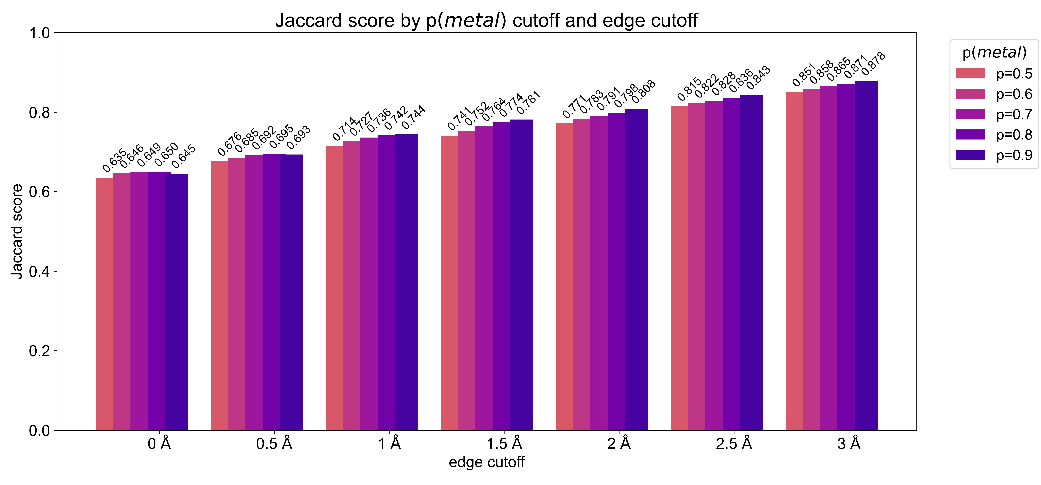

Figure 3: Discretized Jaccard index using different edge cutoffs and different probability cutoffs shows that Metal3D predictions well reproduce the target environments in the test set.

Metal3D is available as self-contained notebook on GoogleColab:

### Selectivity for other metals

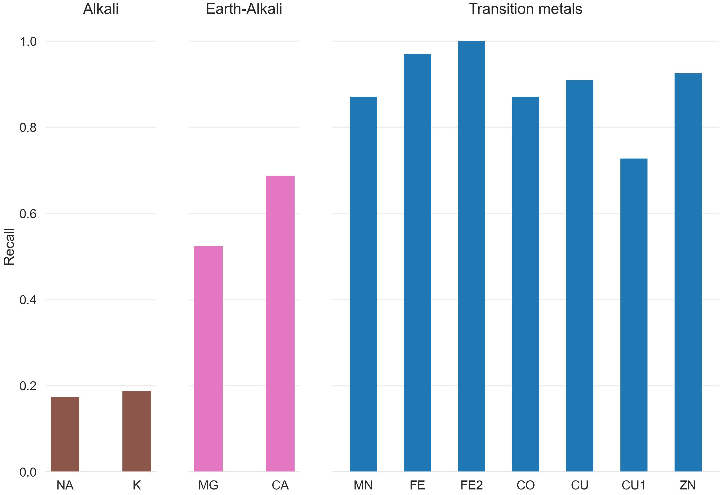

Figure 4: Recall for zinc test set and a 25 randomly drawn structures for other transition, alkali and earth-alkali metals for Metal3D using p=0.5 as cutoff

Trained exclusively on zinc, the performance of Metal1D and Metal3D was assessed on sodium (NA), potassium(K), calcium (CA), magnesium (MG) and various transition metals (PDB codes FE2, FE, CO, CU, CU1, MN, NI) from 25 randomly drawn structures with one or more metalsites. Only sites with a least 2 protein ligands were used for the analysis to exclude crystallographic artefacts. Figure 4 shows that recall for Metal3D is high for all transition metals, meaning that the model correctly finds most sites even though it was only trained on zinc. For the alkali and earth alkali metals recall is much lower as the model only finds some sites. The mean probability for found zinc structures (ZN p= 0.95 ± 0.10) in the test set is higher than for the other transition metals (Figure 14) and significantly higher than for the alkali metals (NA p=0.61 ± 0.10, K p=0.79 ± 0.16). The probability for MG (p=0.77 ± 0.16) is similar to CA (p=0.73 ± 0.16). The MAD for each found metal site is again lowest for zinc (0.56 ± 0.59 Å). The MAD for the found sodium (n=2) and potassium (n=5) sites are as low as for the other transition metals. The only metal with significantly higher MAD (1.45 ± 0.93 Å) is CU1 (Figure 13).

The only two structures where a sodium is detected (2OKQ62, 6KFN63) have at least 2 sidechain ligand atoms and only one backbone (2OKQ) or no backbone ligand atom coordinating it (6KFN). Canonical sodium binding sites e.g such as in PDB 4I0W64 with two backbone carbonyl and one asparagine sidechain have probabilities around 5 % and are basically indistuinguishable from background noise.

For Metal1D overall recall is lower with similar differences in the detection of main group metals versus transition metals (Supplemental figures 11 and 12).

### Comparison of Metal1D, Metal3D, MIB and BioMetAll

Many metal ion predictors exist that can be subdivided into two categories: binding site predictors and binding location predictors. The former label only the residues binding the ion, the latter predict the coordinates of the ion. Both Metal1D and Metal3D can predict the coordinate of putative binding sites. We therefore assessed the performance comparing to recent predictors that also directly predict the location of the metal (BioMetAll, MIB). Other tools such Findsite-metal are no longer available online. MIB uses a fragment method to identify homologous binding sites to the motifs it finds in a given structure and will extract the location of the metal from the homologous structures in its database aligning it to the current site. The main parameter of MIB is the template similarity t with higher values requiring higher similarity of the templates available for the search. BioMetAll was calibrated on availble protein structures and places probes on a regular grid at all sites where the criteria for metalbinding are fulfilled. Probes are associated to a cluster of amino acids. For each cluster of probes also a geometric center of the probes is given which we used to assess performance in this work as there is no individual ranking of the probes given by the program. The main parameter for BioMetAll is the cluster cutoff c which indicates how many probes in reference to the largest cluster a specific cluster has. We used the recommended cutoff of 0.5 requiring all chosen clusters to have at least 50% of the probes of the most populous cluster.  
We first investigated the potential of all tools to detect a metal ion binding site. We defined a correctly identified binding site as a prediction within 5 Å of an experimental zinc site. In case a tool predicted no metal within the 5 Å radius we counted this site as false negative. False positive predictions, i.e sites where a metal was placed spuriously, were clustered and counted once per cluster. When the performance of MIB (t=1.25) and BioMetAll is compared against Metal3D with probability cutoff p=0.75 we find that Metal3D identifies more sites (85) than MIB (78) or BioMetAll (75) with a much lower number of false positives (Figure 5). MIB predicts 180 false positive sites, BioMetAll 134 sites whereas Metal3D only predicts 9 false positive sites at the p=0.75 cutoff. Metal1D (t=0.5) offers similar detection capabilities (78 sites detected) with a lower number of false positives (47) compared to MIB and BioMetAll. As about 1/3 of zinc binding sites in the PDB are artefacts65 we removed 56 sites from the list of zincs in the test set (189 total) that had less than 2 unique protein ligands within 2.8 Å of the experimental zinc. The amount of correct predictions in this reduced set is almost unchanged for all tools (Figure 5) indicating that most tools correctly predict sites only if they have 2 or more protein ligands. For Metal3D at p=0.75 and p=0.9 as well as MIB t=1.9 all sites that are correctly predicted to contain a metal are sites with more than 2 protein ligands. The number of false negatives is reduced for all tools by about 50 sites indicating that most tools do not predict these crystallographic artefacts that might depend on additional coordinating residues from an adjacent molecule in the crystal. Of all tools, Metal3D has the least false positives (1 FP at p=0.9) and the highest number of detected sites (110 at p=0.25). The single false positive at p=0.9 is a calcium binding site with three aspartates and one backbone carbonyl ligand (Figure 16).

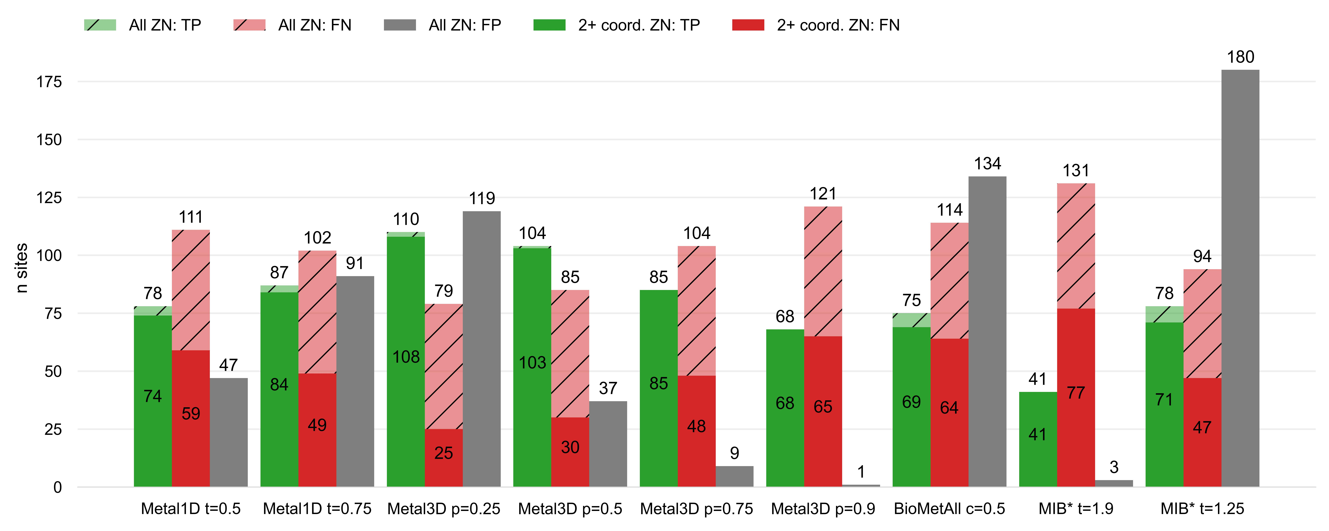

Figure 5: Comparison of Metal1D, Metal3D, BioMetAll and MIB on the test set used to train Metal1D and Metal3D. Predicted sites are counted if within 5 Å of true metal location. False positive probes are clustered and counted once per cluster. *For MIB we used 2 structures less because the server did not accept these structures.

After assessment of how many sites the tools predict, another crucial metric is the spatial precision of the predictions. For the correctly identified sites we measured the mean absolute distance (MAD) between experimental and predicted position (Figure 6). The MAD for Metal3D p=0.9 is 0.70 ± 0.64 Å and 0.73 ± 0.65 Å at p=0.25 indicating that low confidence predictions are still accurate. The median of predictions for Metal3D p=0.9 is 0.52 Å indicating that for half of the predictions the model predicts at or better than the grid resolution of 0.5 Å.

BioMetAll is not very precise with MAD for correctly identified sites of 2.8 ± 1.3 Å. BioMetAll predicts many possible locations per cluster with some of them much closer to the experimental metal than the center. However, within a cluster the probes are not ranked wherefore the cluster center was used for the distance calculation. Metal1D (MAD 2.06 ± 1.33 Å) which identifies more sites than BioMetAll is also slightly more precise than BioMetAll. MIB t=1.9 detects sites with high precision (MAD 0.77 ± 1.09 Å) because it can use homologuous sites to align the found sites on the current site.

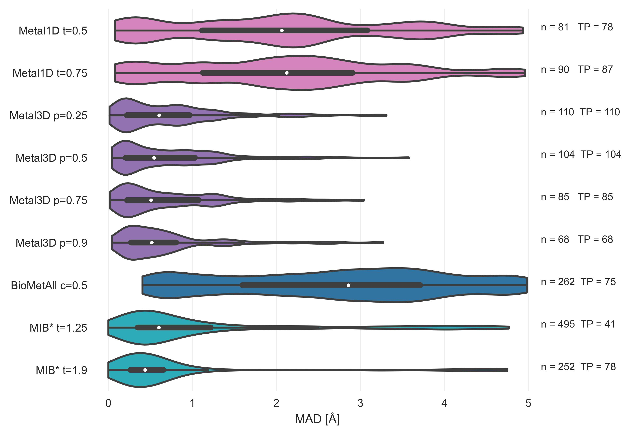

Figure 6: Mean absolute deviation of predicted location of zincs using Metal1D, Metal3D, BioMetAll and MIB on the test set used to train Metal1D and Metal3D for all correctly identified sites. n is the number of sites predicted by the tool, TP is the number of unique sites. *For MIB we used 2 structures less because the server did not accept these structures.

### Applications

#### Alpha Fold

AlphaFold often predicts sidechains in metal ion binding sites in the holo conformation.27 Services like AlphaFill23 use structural homology to transplant metals from similar PDB structures to the predicted structure. Metal3D does not use explicit homology based on sequence alignment like AlphaFill does so it would potentially be suited to annotated the dark proteome that is now accessible from the AlphaFold database with metal ions. Metal3D identifies both the structural and catalytic site for the example (PDB 3RZV66 , Figure 7) used in ref23 with high probability (p=0.99) even though one of the sites in the AlphaFold model is slightly disordered with one of the binding residues in the solvent facing conformation (D309). The distances between predicted and modelled metal locations for Metal3D are 0.22 Å and 0.37 Å, for AlphaFill they are 0.21 Å and 0.41 Å.

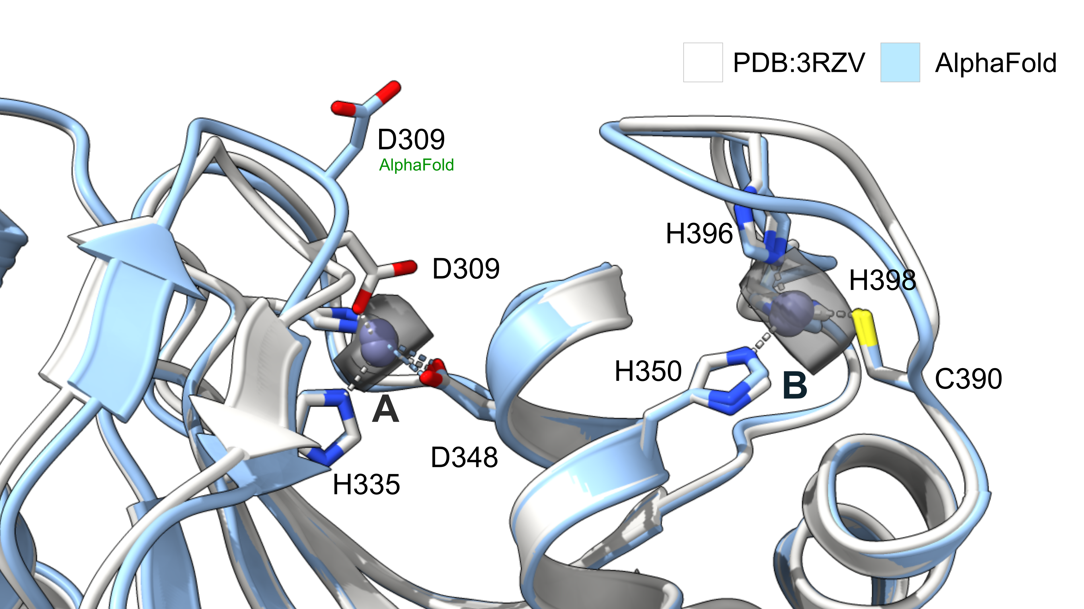

Figure 7: Metal3D, AlphaFill and experimental zinc positions. Metal3D places the metal with high accuracy even if coordination is not perfectly predicted by AlphaFold. Experimental structure (PDB 3RZV) in white cartoon, AlphaFold2 model in light blue cartoon. Probability isosurface colored at p=0.6 in gray.

#### Protein engineering

Human carbonic anhydrase II (HCA2) is a well studied metalloenzyme with a rich amount of mutational data available. On the wildtype enzyme crystal structure (PDB 2CBA59) Metal3D recapitulates the location of the active site metal when using a high probability cutoff (p>0.4) with the RMSD to the true metal location at 0.21 Å and the probability of the experimental site predicted at p=0.99. At lower probability cutoffs the probability map indicates further putative metal ion binding sites with interactions mediated by surface residues (H36, D110, p=0.4) (Figure 8).

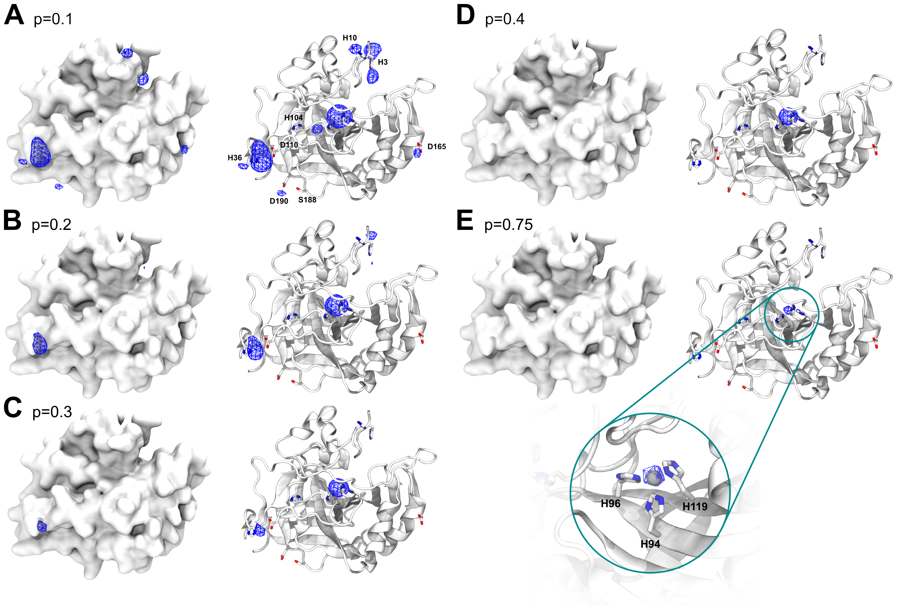

Figure 8: Probability evolution in HCA2 for different probability cutoffs A) p=0.1 B) p=0.2 C) p=0.3 D) p=0.4 E) p= 0.75

To investigate the capabilities for protein engineering we used mutational data for first and second shell mutants of the active site residues in HCA2. The dataset comprises Kd values from a calorimetric assay.67 For most mutants no crystal structures are available so we used the structure builder in the EVOLVE package to choose the most favorable rotamer for each single point mutation based on the EVOLVE-ddg energy function with explicit zinc present (modeled using dummy atom approach). The analysis was run for each single mutant and the resulting probability maps were analyzed. For the analysis we used the maximum predicted probability as a surrogate to estimate relative changes in Kd. For mutants that decrease zinc binding drastically we observe a drop in probability (Figure 9). The lowest probability mutants are H119N and H119Q with p=0.23 and 0.38. The mutant with the biggest loss in zinc affinity H94A has a zinc binding probability of p=0.6. Conservative changes to the primary coordination motif (e.g H → C) reduce the predicted probability by 10 - 30 %. For second shell mutants the influence of the mutations is less drastic with only minor changes in the predicted probabilities.

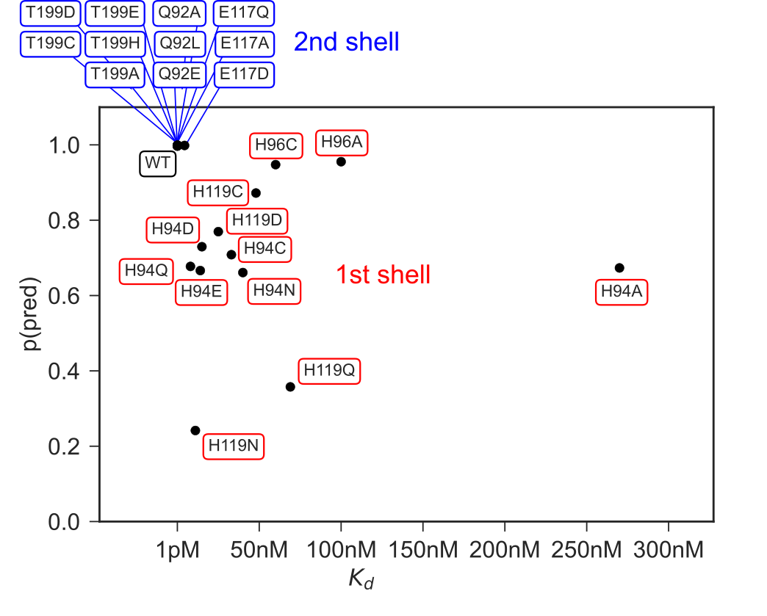

Figure 9: Experimentally measured KD values53–57 for 1st and 2nd shell active site mutants of HCA and predicted max probability for zinc using Metal3D.

## Discussion

Metal3D predicts the probability distribution of zinc in protein crystal structures based on a model trained on natural protein environments. The model performs a segmentation task to determine if a specific point in the input space contains zinc or not. Metal3D predicts zinc sites with high accuracy making use of high resolution crystal structures (<2.5 Å). The use of high resolution structures is necessary because at resolution greater than the average zinc ligand coordination distance (2.2 Å) the uncertainty of the zinc location noticeably increases65 which would likely hamper the accuracy of the model. In contrast to currently available tools, for Metal3D we did not filter the training examples for certain coordination requirements (i.e only sites with at least 2 protein ligands). This allows the model to also predict sites with partial coordination. Such a model is necessary as protein design software requires models to score the full continuum of zinc sites starting from a nucleus binding site to a highly organized zinc site in an enzyme. The predicted probability can be used as a confidence metric or as optimization target where mutations are made to increase probability of zinc binding. Methods which rely on homology such as MIB perform worse on partial binding sites because reducing the quality of the available templates by including 1- or 2-coordinate sites would yield many false positives (similar to including less homologous structures for the template search). The same is true for distance based predictors such as Metal1D. In order to reduce the amount of false positives, low quality sites need to be excluded during training of those models. The deep learning based Metal3D likely can circumvent this because it does not require any engineered features to predict the location of the metal and learns directly from a full representation of the environment surrounding the binding pocket. This allows to look at low confidence sites in the context of the given environment.

### Influence of non-protein ligands

The majority of sites in the training set are well coordinated sites and during training the model can relate the frequency of different zinc ion binding motifs in the training set with the probability of metal presence. The fraction of artifactual zinc binding site in the PDB is estimated to be about 1/365 similar to the test set used with 70% (133) well coordinated zinc sites. As we train on biological assemblies some of those binding sites might be located at the surface of the assembly whereas in the asymmetric unit of the crystal they might form part of a crystal contact. The model was presented with as many complete sites as possible by using crystal symmetry to add the symmetry adjacent protein chains. However, non-protein ligands e.g water or organic ligands are not included. For some sites the model is therefore missing information on one or more coordination partners.

Empty coordination sites of metals are filled with water molecules in case there is no other exogenous ligand with higher affinity present (e.g a thiol). Both Metal1D and Metal3D do not consider water molecules or other ligands in the input as the quality of ligand molecules in the PDB varies.68. In addition, other potential sources of input such as AlphaFold do not provide explicit waters wherefore models should not rely on water as an input source. Moreover, in protein design algorithms water is usually only implicitly modeled (e.g in Rosetta). Common water placement algorithms to place deep waters69,70 are not able to take into account the presence of metal ions when placing water molecules. For Metal3D the input channel that encodes the total heavy atom density however encodes an implicit water density where all empty space can be interpreted as the solvent. For Metal1D, the contribution of water molecules is considered in an implicit way when the score is assigned to a site by considering coordinations including water compatible to the one observed (for example, the weight of a HHHO coordination in the probability map, where O is a water molecule, is added to the total score in case of a HHH coordination available).

### Choice of architecture

This work is the first to report a modern deep learning based model destined for identification of metal ligands in proteins. Placement of a metal ion is similar to protein-ligand docking where a variety of architectures and representations have been used. 3D CNN based approaches such as LigVoxel37 and DeepSite36 commonly use a resolution of 1 Å and similar input features as our model to predict the ligand density. However, predicting the density of a multi-atomic ligand is more complex than predicting the density of mononuclear metal ions. We therefore did not deem it necessary to include a conditioning on how many metal ions are present in the box and rather chose to reflect this in the training data where the model needs to learn that only about half of the environments it sees contain one or more metals. This choice is validated by the fact that the output probability densities at sufficiently high probability cutoff are spherical with their radius approximately matching the van der Waals radius of zinc.

Mesh convolutional neural networks trained on a protein surface representation35 also have been used to predict the location and identity of protein ligands but this approach can only label the regions of the surface that bind the metal ion is conceptually not able to return the exact location of the metal. Some metal ion binding sites are also heavily buried inside proteins as they mediate structural stability rendering them inaccessible to a surface based approach. The most recent approaches such as EquiBind38 use equivariant neural networks such as En-Transformer71 to predict binding keypoints (defined as 1/2 distance between the Cɑ of the binding residue and a ligand atom). Explicit sidechains are still too expensive for such models and these models assume a fixed known stoichiometry of the protein and ligand. Metal3D can also deal with proteins that do not bind a metal and does not assume that the amount of zinc ions is known. The lack of explicit sidechain information renders equivariant models unsuitable for the design of complex metal ion binding sites supported by an intricate network of hydrogen bonds that need to be positioned with sub-angstrom accuracy. Our model in contrast is less data-efficient than approaches representing the protein as graph due to the need to voxelize the input and provide different rotations of the input environment in training. For inference our model is fast with about 25 seconds processing time for a 250 residue protein on a multicore GPU workstation.  
In contrast to sequence based models72,73 our model is more data-efficient and better suited to be integrated into structure based design workflows such as Rosetta or EVOLVE. Sequence based approaches can only use coevolution signals to infer residues in spatial proximity that can bind a metal. This might be difficult when it comes to ranking similar amino acids such as aspartate and glutamate or even ranking different rotamers where sub-angstrom level precision is needed to identify the mutant with the highest affinity for zinc.

### Selectivity

In terms of selectivity both of our methods have a clear preference for transition metals over main group metals after having been trained exclusively on zinc binding sites. The only sites that Metal3D identifies for sodium in the test set are the ones that have sidechain ligands. Many sodium and potassium sites are using backbone carbonyl coordination exclusively, which is not common for zinc and those sites are therefore not detected. It has recently been demonstrated how a specific transition metal can be selectively bound to a protein.74 This however was only achieved using non-ideal coordination which is better tolerated by some transition metals due to the different electronic configurations. It is likely impossible to train a predictor that can perfectly discriminate zinc from e.g copper and nickel sites because the natural coordination environments and coordination distances within the given resolution threshold are almost indistinguishable with many sites being promiscous. The availability of specific metals inside the organism is heavily compartmentalized, therefore an approach using solely the structure will be unable to capture the full selectivity. In addition, sometimes non-native metals are used for crystallization experiments because the reaction catalyzed by an active site metal might exhibit different kinetics with different metals. The metal in the deposited structure might therefore not be the native metal. In this work we chose to work with zinc only because it is redox stable and because many training environments are available. Our scheme could be rapidly adapted to train a predictor that outputs different channels for different metals.

### Application for protein design

Protein design using 3DCNNs trained on residue identity has been successfully demonstrated and we anticipate that our model could be seamlessly integrated into such a workflow31 to enable fully deep learning based design of metalloproteins. We are currently investigating the combination of Metal3D combined with a classic energy-based genetic algorithm-based optimization to make design of metalloproteins easier without having to model explicitly the metal to compute the stability of the protein. As the model computes a probability density per residue it can be readily integrated in standard workflows relying on rotamer sampling.

The HCA2 application demonstrates the utility of Metal3D for protein engineering (Figure 8). The kinetics of metal ion binding to proteins are complicated75 and there are currently no high-throughput based approaches that could generate a dataset large enough to train a model directly on predicting Kd. The data we use were obtained from a colorimetric assay predicting very high affinity of zinc in the picomolar range.53–57 More recent studies using ITC75 instead of the colorimetric assay indicate lower Kd values in the nanomolar range for the wild type. We can therefore only use the colorimetric data to estimate how well the model can recapitulate relative changes in the Kd for different mutations in the first and second shell of a prototypical metalloprotein.

Metal3D allows moving away from using rational approaches such as the i, i + 4 diHis motifs used for the assembly and stabilization of metalloproteins and peptides through coordination of divalent transition metal ions to a fully automated approach where potential metalbinding configurations can be scored computationally instead of relying on manual verification.76–78

### Metal1D vs. Metal3D

Metal1D is inferior to Metal3D for the prediction of metal ion binding sites because it produces more false positives while at the same time detecting fewer metal sites. This demonstrates the inherent limitation of using solely distance based features for prediction of metal location. BioMetAll which is the tool most similar to Metal1D also suffers from many false positive predictions.

## Conclusion

We present two metal ion location predictors: Metal3D based on 3D convolutional neural networks and Metal1D based on distances. Metal3D is the first tool with sub-angstrom level precision to predict the location of metal ions in proteins that does not rely on searching for structurally homologous proteins in a database. We anticipate different applications such as protein-function annotation using structures predicted using AlphaFold,79 integration in protein design software and detection of cryptic metal binding sites that can be used to engineer PPIs. Such cryptic metal ion binding sites in common drug targets could also be used to engineer novel metallodrugs. Many of these applications allow to explore the still vastly untapped potential of proteins as large programmable multi-dentate metal ligands with tunable surfaces.

## Additional information

### Conflict of interest

None declared

### Author contributions

S.L.D and A.L designed research, S.L.D, A.L, U.R conceptualized research, S.L.D and A.L developed methodology and software, S.L.D and A.L wrote first draft, S.L.D, A.L, U.R revised and edited draft, U.R supervised research and aquired funding.

## Supplement

### Metal1D

Table 1: Atoms used as reference points for each amino acid in Metal1D. In case of amino acids with more than one possible ligand atom, the search radius is enlarged, the increase is computed from the midpoint between all ligating atoms. Typical values computed for structure data files downloaded from the PDB are reported.

|  |  |  |  |
| --- | --- | --- | --- |
| Amino acid | Residue name | Label(s) | Search radius increase (Å) |
| Alanine | ALA | O | 0 |
| Arginine | ARG | NH1, NH2 | 1.2 |
| Asparagine | ASN | OD1 | 0 |
| Aspartic acid | ASP | OD1, OD2 | 1.105 |
| Cysteine | CYS | SG | 0 |
| Glutamic acid | GLU | OE1, OE2 | 1.105 |
| Glutamine | GLN | OE1 | 0 |
| Glycine | GLY | O | 0 |
| Histidine | HIS | ND1, ND2 | 1.08 |
| Isoleucine | ILE | O | 0 |
| Leucine | LEU | O | 0 |
| Lysine | LYS | NZ | 0 |
| Methionine | MET | SD | 0 |
| Phenylalanine | PHE | O | 0 |
| Proline | PRO | O | 0 |
| Serine | SER | OG | 0 |
| Threonine | THR | OG1 | 0 |
| Tryptophan | TRP | O | 0 |
| Tyrosine | TYR | OH | 0 |
| Valine | VAL | OH | 0 |

### Precision/Recall

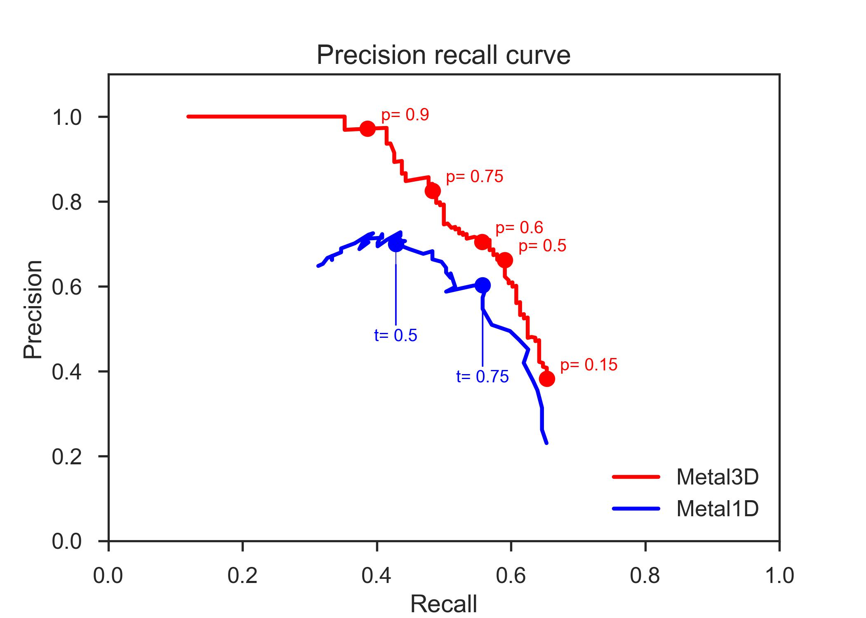

Figure 10: Precision recall curve for Metal1D and Metal3D with the probability cutoffs (Metal3D) or thresholds (Metal1D) used in the analysis.

### Metal selectivity

#### Metal1D

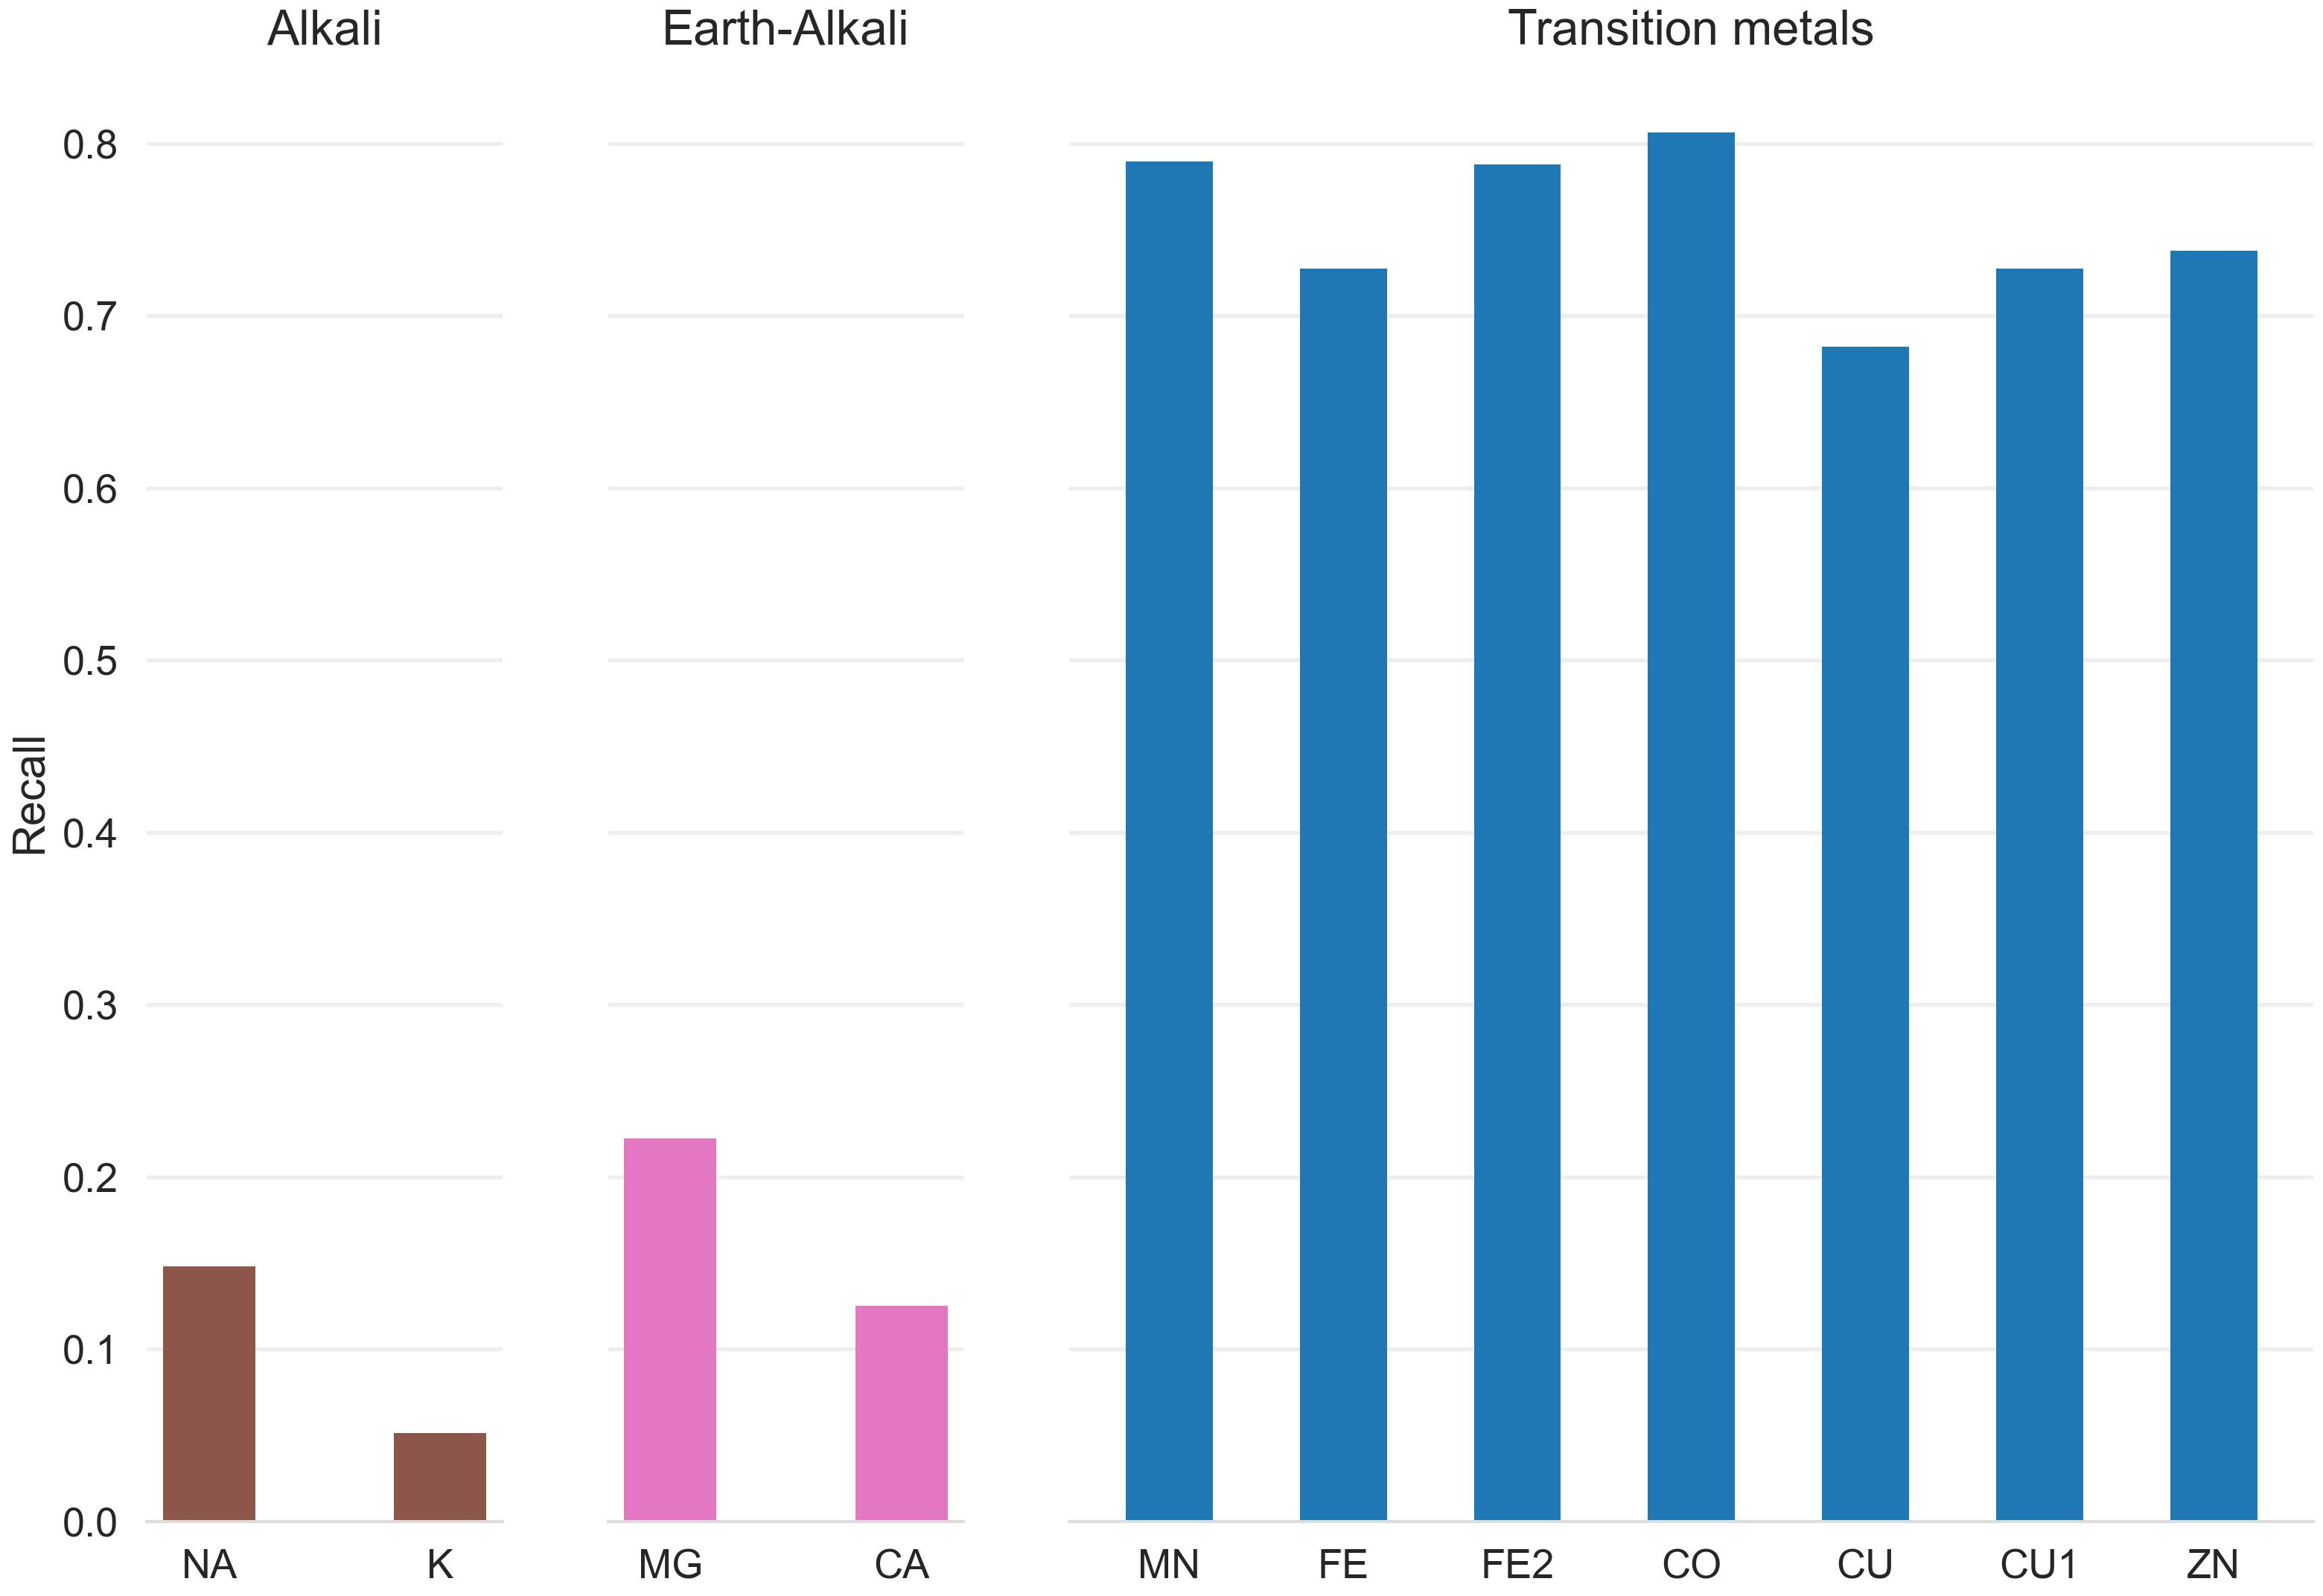

Figure 11: Recall for zinc testset and a 25 randomly drawn structures for other transition, alkali and earth-alkali metals for Metal1D

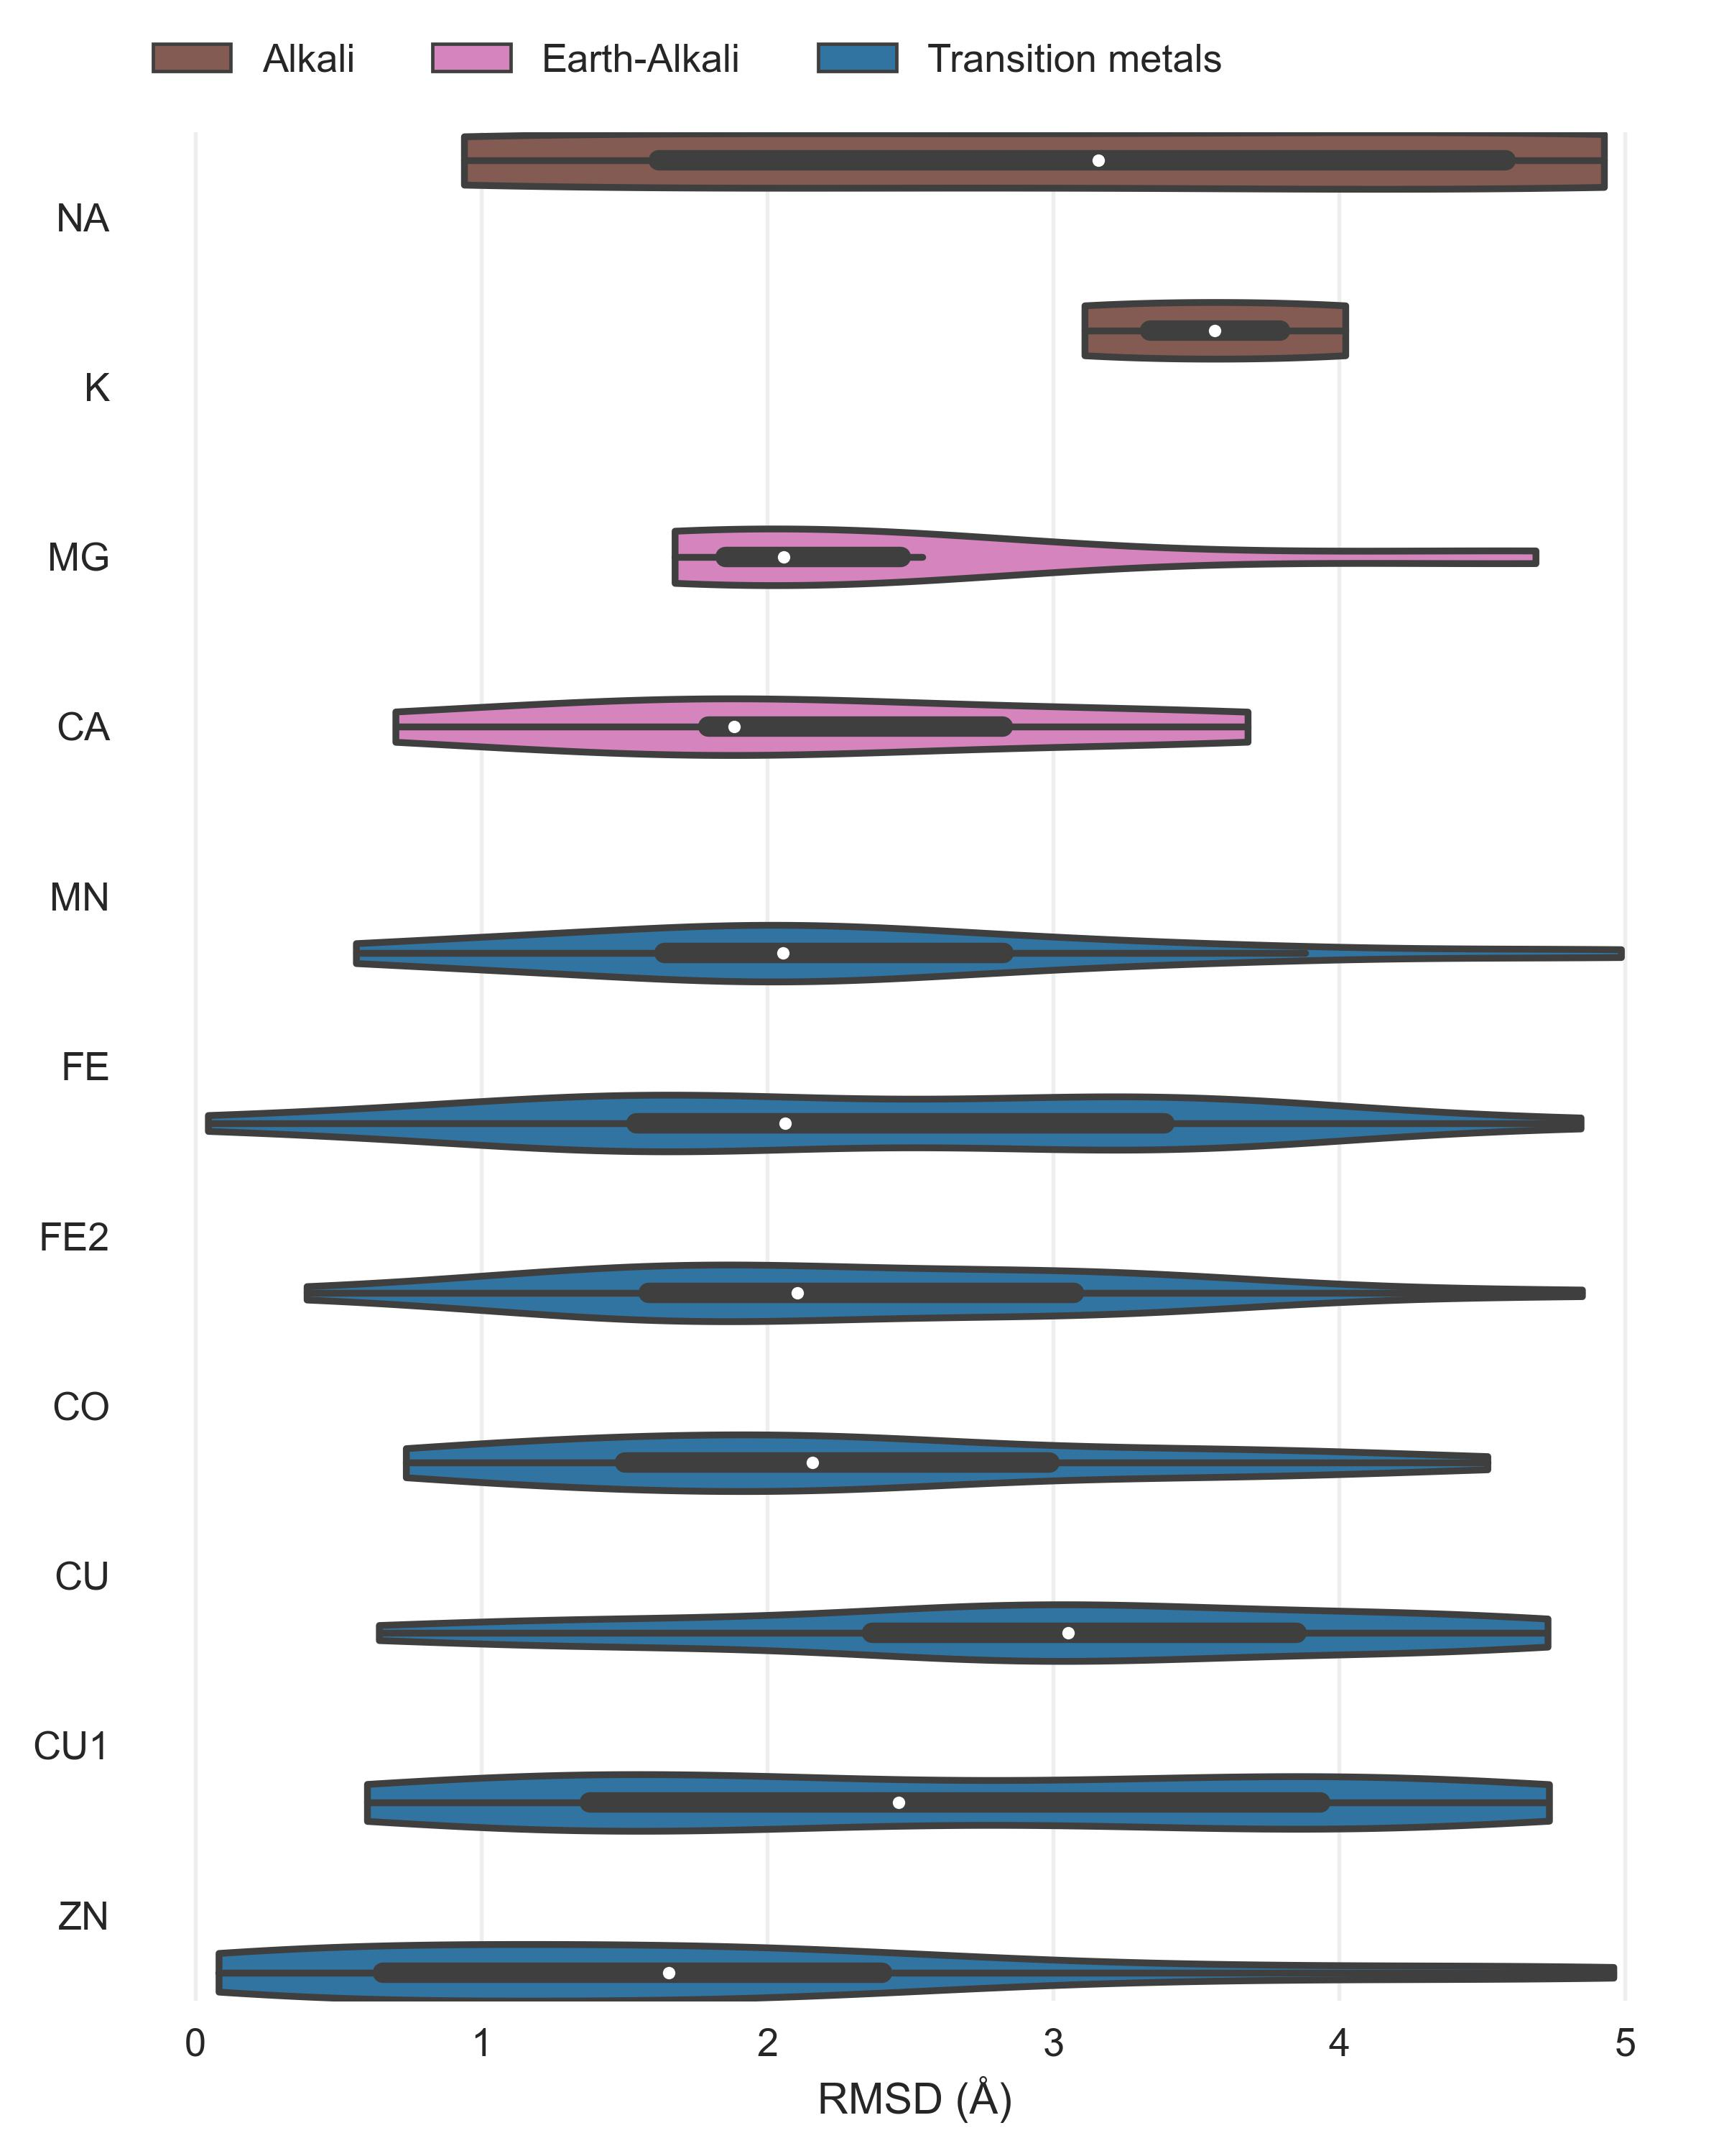

Figure 12: Distance distribution Metal1D

#### Metal3D

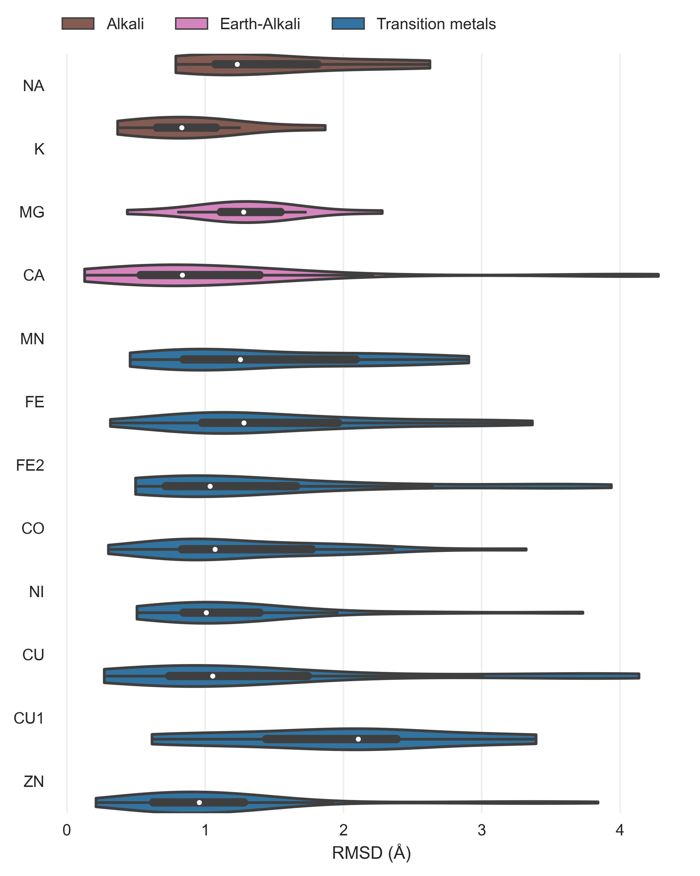

Figure 13: MAD for Metal3D on all true positive predictions in the test set.

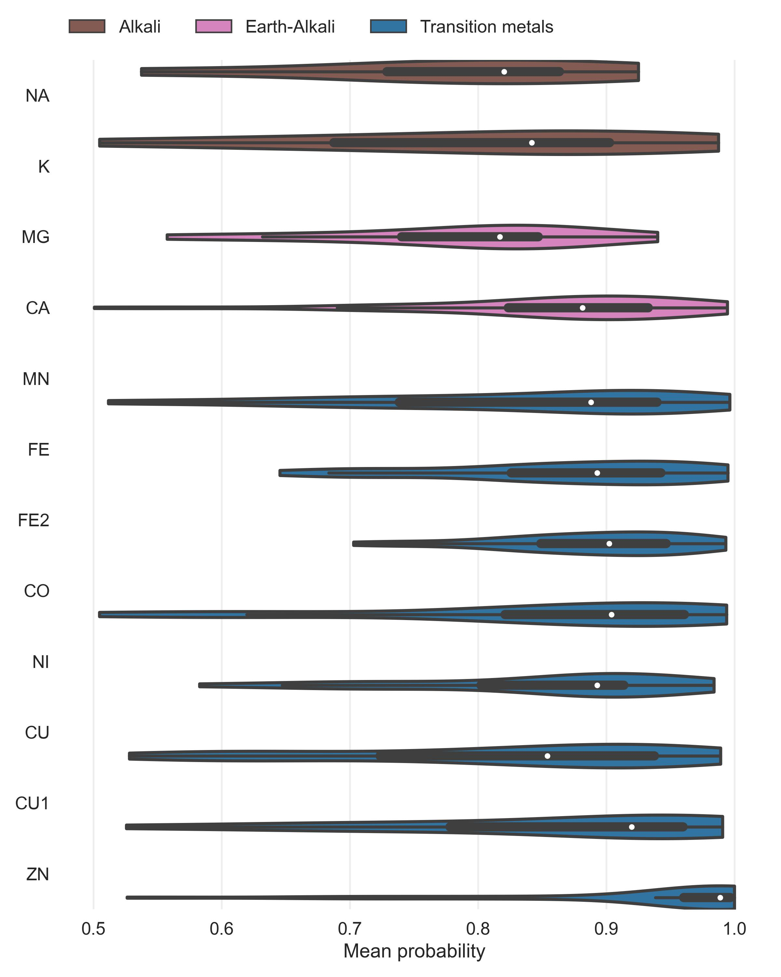

Figure 14: Probability distribution for Metal3D on all true positive predictions in the test set.

### Comparison

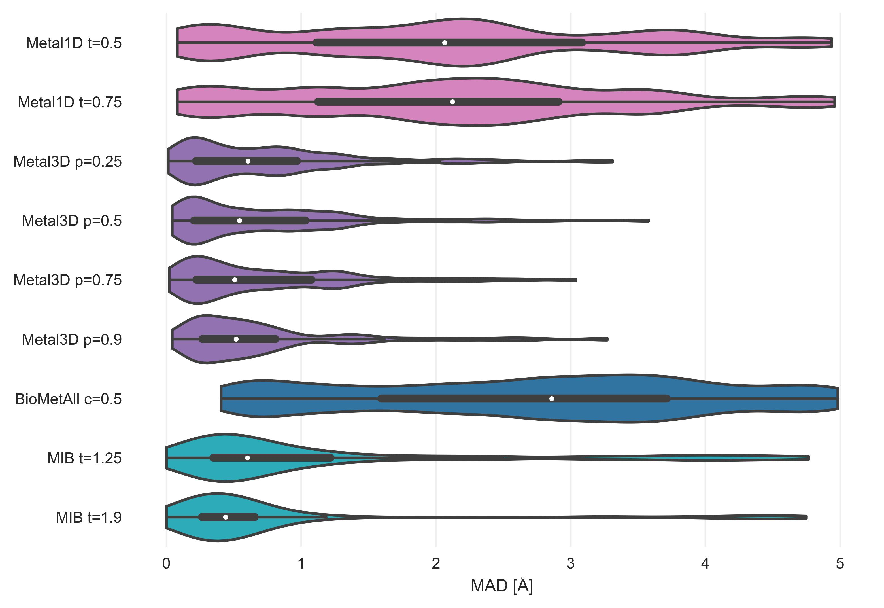

Figure 15: MAD only 2 residue coordinated zincs

##### Mean absolute deviations

The measured MAD for all true positive zinc sites for each tool in the database.

Table 2: MAD and median on zinc test set for all zinc sites (n=189).

|  |  |  |
| --- | --- | --- |
| tool | MAD [Å] | median [Å] |
| BioMetAll c=0.5 | 2.72 ± 1.33 | 2.86 |
| MIB t=1.25 | 1.13 ± 1.24 | 0.60 |
| MIB t=1.9 | 0.77 ± 1.09 | 0.44 |
| Metal1D t=0.5 | 2.07 ± 1.33 | 2.06 |
| Metal1D t=0.75 | 2.19 ± 1.26 | 2.12 |
| Metal3D p=0.25 | 0.74 ± 0.66 | 0.61 |
| Metal3D p=0.5 | 0.73 ± 0.66 | 0.54 |
| Metal3D p=0.75 | 0.71 ± 0.64 | 0.51 |
| Metal3D p=0.9 | 0.70 ± 0.64 | 0.52 |

Table 3: MAD and median on zinc test set for zinc sites with at least 2 protein ligands (n=133).

|  |  |  |
| --- | --- | --- |
| tool | MAD [Å] | median [Å] |
| BioMetAll c=0.5 | 2.68 ± 1.33 | 2.84 |
| MIB t=1.25 | 1.09 ± 1.21 | 0.60 |
| MIB t=1.9 | 0.77 ± 1.09 | 0.44 |
| Metal1D t=0.5 | 1.97 ± 1.29 | 1.99 |
| Metal1D t=0.75 | 2.06 ± 1.24 | 2.09 |
| Metal3D p=0.25 | 0.69 ± 0.58 | 0.56 |
| Metal3D p=0.5 | 0.69 ± 0.59 | 0.54 |
| Metal3D p=0.75 | 0.71 ± 0.64 | 0.51 |
| Metal3D p=0.9 | 0.70 ± 0.64 | 0.52 |

##### False positive Metal3D p=0.9

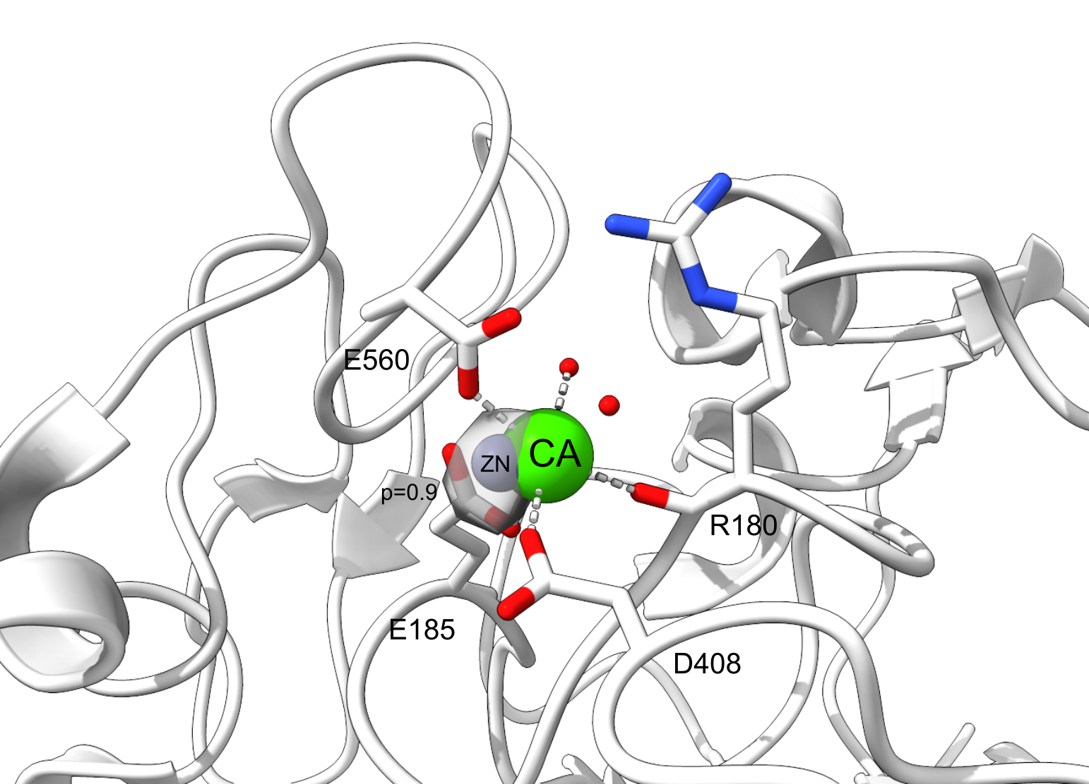

Figure 16: False positive for Metal3D at p=0.9 in PDB 4JJJ. A calcium site is misclassified as zinc site.

## References

(1) Yu, F.; Cangelosi, V. M.; Zastrow, M. L.; Tegoni, M.; Plegaria, J. S.; Tebo, A. G.; Mocny, C. S.; Ruckthong, L.; Qayyum, H.; Pecoraro, V. L. Protein Design: Toward Functional Metalloenzymes. *Chem. Rev.* **2014**, *114* (7), 3495–3578. <https://doi.org/10.1021/cr400458x>.

(2) Guffy, S. L.; Der, B. S.; Kuhlman, B. Probing the Minimal Determinants of Zinc Binding with Computational Protein Design. *Protein Engineering, Design and Selection* **2016**, *29* (8), 327–338. <https://doi.org/10.1093/protein/gzw026>.

(3) Andreini, C.; Bertini, I.; Cavallaro, G.; Holliday, G. L.; Thornton, J. M. Metal Ions in Biological Catalysis: From Enzyme Databases to General Principles. *J Biol Inorg Chem* **2008**, *13* (8), 1205–1218. <https://doi.org/10.1007/s00775-008-0404-5>.

(4) Koohi-Moghadam, M.; Wang, H.; Wang, Y.; Yang, X.; Li, H.; Wang, J.; Sun, H. Predicting Disease-Associated Mutation of Metal-Binding Sites in Proteins Using a Deep Learning Approach. *Nat Mach Intell* **2019**, *1* (12), 561–567. <https://doi.org/10.1038/s42256-019-0119-z>.

(5) Studer, S.; Hansen, D. A.; Pianowski, Z. L.; Mittl, P. R. E.; Debon, A.; Guffy, S. L.; Der, B. S.; Kuhlman, B.; Hilvert, D. Evolution of a Highly Active and Enantiospecific Metalloenzyme from Short Peptides. *Science* **2018**, *362* (6420), 1285–1288. <https://doi.org/10.1126/science.aau3744>.

(6) Key, H. M.; Dydio, P.; Clark, D. S.; Hartwig, J. F. Abiological Catalysis by Artificial Haem Proteins Containing Noble Metals in Place of Iron. *Nature* **2016**, *534* (7608), 534–537. <https://doi.org/10.1038/nature17968>.

(7) Der, B. S.; Edwards, D. R.; Kuhlman, B. Catalysis by a de Novo Zinc-Mediated Protein Interface: Implications for Natural Enzyme Evolution and Rational Enzyme Engineering. *Biochemistry* **2012**, *51* (18), 3933–3940. <https://doi.org/10.1021/bi201881p>.

(8) Fujieda, N.; Schätti, J.; Stuttfeld, E.; Ohkubo, K.; Maier, T.; Fukuzumi, S.; Ward, T. R. Enzyme Repurposing of a Hydrolase as an Emergent Peroxidase Upon Metal Binding. *Chem. Sci.* **2015**, *6* (7), 4060–4065. <https://doi.org/10.1039/c5sc01065a>.

(9) Brodin, J. D.; Ambroggio, X. I.; Tang, C.; Parent, K. N.; Baker, T. S.; Tezcan, F. A. Metal-Directed, Chemically Tunable Assembly of One-, Two- and Three-Dimensional Crystalline Protein Arrays. *Nature Chem* **2012**, *4* (5), 375–382. <https://doi.org/10.1038/nchem.1290>.

(10) Der, B. S.; Machius, M.; Miley, M. J.; Mills, J. L.; Szyperski, T.; Kuhlman, B. Metal-Mediated Affinity and Orientation Specificity in a Computationally Designed Protein Homodimer. *J. Am. Chem. Soc.* **2011**, *134* (1), 375–385. <https://doi.org/10.1021/ja208015j>.

(11) Salgado, E. N.; Radford, R. J.; Tezcan, F. A. Metal-Directed Protein Self-Assembly. *Acc. Chem. Res.* **2010**, *43* (5), 661–672. <https://doi.org/10.1021/ar900273t>.

(12) Kakkis, A.; Gagnon, D.; Esselborn, J.; Britt, R. D.; Tezcan, F. A. Metal‐Templated Design of Chemically Switchable Protein Assemblies with High‐Affinity Coordination Sites. *Angew. Chem. Int. Ed.* **2020**, *59* (49), 21940–21944. <https://doi.org/10.1002/anie.202009226>.

(13) Zastrow, M. L.; Peacock, A. F. A.; Stuckey, J. A.; Pecoraro, V. L. Hydrolytic Catalysis and Structural Stabilization in a Designed Metalloprotein. *Nature Chem* **2011**, *4* (2), 118–123. <https://doi.org/10.1038/nchem.1201>.

(14) Song, L. F.; Sengupta, A.; Merz, K. M., Jr. Thermodynamics of Transition Metal Ion Binding to Proteins. *J. Am. Chem. Soc.* **2020**, *142* (13), 6365–6374. <https://doi.org/10.1021/jacs.0c01329>.

(15) Alford, R. F.; Leaver-Fay, A.; Jeliazkov, J. R.; O’Meara, M. J.; DiMaio, F. P.; Park, H.; Shapovalov, M. V.; Renfrew, P. D.; Mulligan, V. K.; Kappel, K.; Labonte, J. W.; Pacella, M. S.; Bonneau, R.; Bradley, P.; Dunbrack, R. L., Jr.; Das, R.; Baker, D.; Kuhlman, B.; Kortemme, T.; Gray, J. J. The Rosetta All-Atom Energy Function for Macromolecular Modeling and Design. *J. Chem. Theory Comput.* **2017**, *13* (6), 3031–3048. <https://doi.org/10.1021/acs.jctc.7b00125>.

(16) Brunk, E.; Rothlisberger, U. Mixed Quantum Mechanical/Molecular Mechanical Molecular Dynamics Simulations of Biological Systems in Ground and Electronically Excited States. *Chem. Rev.* **2015**, *115* (12), 6217–6263. <https://doi.org/10.1021/cr500628b>.

(17) Yang, Z.; Twidale, R. M.; Gervasoni, S.; Suardíaz, R.; Colenso, C. K.; Lang, E. J. M.; Spencer, J.; Mulholland, A. J. Multiscale Workflow for Modeling Ligand Complexes of Zinc Metalloproteins. *J. Chem. Inf. Model.* **2021**, *61* (11), 5658–5672. <https://doi.org/10.1021/acs.jcim.1c01109>.

(18) Bozkurt, E.; Perez, M. A. S.; Hovius, R.; Browning, N. J.; Rothlisberger, U. Genetic Algorithm Based Design and Experimental Characterization of a Highly Thermostable Metalloprotein. *J. Am. Chem. Soc.* **2018**, *140* (13), 4517–4521. <https://doi.org/10.1021/jacs.7b10660>.

(19). <https://doi.org/10.3389/fchem.2021.692200>.

(20) Passerini, A.; Andreini, C.; Menchetti, S.; Rosato, A.; Frasconi, P. Predicting Zinc Binding at the Proteome Level. *BMC Bioinformatics* **2007**, *8* (1). <https://doi.org/10.1186/1471-2105-8-39>.

(21) Hu, X.; Dong, Q.; Yang, J.; Zhang, Y. Recognizing Metal and Acid Radical Ion-Binding Sites by Integratingab Initiomodeling with Template-Based Transferals. *Bioinformatics* **2016**, *32* (21), 3260–3269. <https://doi.org/10.1093/bioinformatics/btw396>.

(22) Lin, Y.-F.; Cheng, C.-W.; Shih, C.-S.; Hwang, J.-K.; Yu, C.-S.; Lu, C.-H. MIB: Metal Ion-Binding Site Prediction and Docking Server. *J. Chem. Inf. Model.* **2016**, *56* (12), 2287–2291. <https://doi.org/10.1021/acs.jcim.6b00407>.

(23) Hekkelman, M. L.; de Vries, I.; Joosten, R. P.; Perrakis, A. AlphaFill: Enriching the AlphaFold Models with Ligands and Co-Factors, 2021. <https://doi.org/10.1101/2021.11.26.470110>.

(24) Brylinski, M.; Skolnick, J. FINDSITE-Metal: Integrating Evolutionary Information and Machine Learning for Structure-Based Metal-Binding Site Prediction at the Proteome Level. *Proteins* **2010**, *79* (3), 735–751. <https://doi.org/10.1002/prot.22913>.

(25) Sánchez-Aparicio, J.-E.; Tiessler-Sala, L.; Velasco-Carneros, L.; Roldán-Martín, L.; Sciortino, G.; Maréchal, J.-D. BioMetAll: Identifying Metal-Binding Sites in Proteins from Backbone Preorganization. *J. Chem. Inf. Model.* **2020**, *61* (1), 311–323. <https://doi.org/10.1021/acs.jcim.0c00827>.

(26) Haberal, İ.; Oğul, H. Prediction of Protein Metal Binding Sites Using Deep Neural Networks. *Mol. Inf.* **2019**, *38* (7), 1800169. <https://doi.org/10.1002/minf.201800169>.

(27) Jumper, J.; Evans, R.; Pritzel, A.; Green, T.; Figurnov, M.; Ronneberger, O.; Tunyasuvunakool, K.; Bates, R.; Žídek, A.; Potapenko, A.; Bridgland, A.; Meyer, C.; Kohl, S. A. A.; Ballard, A. J.; Cowie, A.; Romera-Paredes, B.; Nikolov, S.; Jain, R.; Adler, J.; Back, T.; Petersen, S.; Reiman, D.; Clancy, E.; Zielinski, M.; Steinegger, M.; Pacholska, M.; Berghammer, T.; Bodenstein, S.; Silver, D.; Vinyals, O.; Senior, A. W.; Kavukcuoglu, K.; Kohli, P.; Hassabis, D. Highly Accurate Protein Structure Prediction with AlphaFold. *Nature* **2021**, *596* (7873), 583–589. <https://doi.org/10.1038/s41586-021-03819-2>.

(28) Baek, M.; DiMaio, F.; Anishchenko, I.; Dauparas, J.; Ovchinnikov, S.; Lee, G. R.; Wang, J.; Cong, Q.; Kinch, L. N.; Schaeffer, R. D.; Millán, C.; Park, H.; Adams, C.; Glassman, C. R.; DeGiovanni, A.; Pereira, J. H.; Rodrigues, A. V.; van Dijk, A. A.; Ebrecht, A. C.; Opperman, D. J.; Sagmeister, T.; Buhlheller, C.; Pavkov-Keller, T.; Rathinaswamy, M. K.; Dalwadi, U.; Yip, C. K.; Burke, J. E.; Garcia, K. C.; Grishin, N. V.; Adams, P. D.; Read, R. J.; Baker, D. Accurate Prediction of Protein Structures and Interactions Using a Three-Track Neural Network. *Science* **2021**, *373* (6557), 871–876. <https://doi.org/10.1126/science.abj8754>.

(29) Torng, W.; Altman, R. B. 3D Deep Convolutional Neural Networks for Amino Acid Environment Similarity Analysis. *BMC Bioinformatics* **2017**, *18* (1). <https://doi.org/10.1186/s12859-017-1702-0>.

(30) Shroff, R.; Cole, A. W.; Diaz, D. J.; Morrow, B. R.; Donnell, I.; Annapareddy, A.; Gollihar, J.; Ellington, A. D.; Thyer, R. Discovery of Novel Gain-of-Function Mutations Guided by Structure-Based Deep Learning. *ACS Synth. Biol.* **2020**, *9* (11), 2927–2935. <https://doi.org/10.1021/acssynbio.0c00345>.

(31) Anand, N.; Eguchi, R.; Mathews, I. I.; Perez, C. P.; Derry, A.; Altman, R. B.; Huang, P.-S. Protein Sequence Design with a Learned Potential. *Nat Commun* **2022**, *13* (1). <https://doi.org/10.1038/s41467-022-28313-9>.

(32) Torng, W.; Altman, R. B. High Precision Protein Functional Site Detection Using 3D Convolutional Neural Networks. *Bioinformatics* **2018**, *35* (9), 1503–1512. <https://doi.org/10.1093/bioinformatics/bty813>.

(33) Feehan, R.; Franklin, M. W.; Slusky, J. S. G. Machine Learning Differentiates Enzymatic and Non-Enzymatic Metals in Proteins. *Nat Commun* **2021**, *12* (1). <https://doi.org/10.1038/s41467-021-24070-3>.

(34) Renaud, N.; Geng, C.; Georgievska, S.; Ambrosetti, F.; Ridder, L.; Marzella, D. F.; Réau, M. F.; Bonvin, A. M. J. J.; Xue, L. C. DeepRank: A Deep Learning Framework for Data Mining 3D Protein-Protein Interfaces. *Nat Commun* **2021**, *12* (1). <https://doi.org/10.1038/s41467-021-27396-0>.

(35) Gainza, P.; Sverrisson, F.; Monti, F.; Rodolà, E.; Boscaini, D.; Bronstein, M. M.; Correia, B. E. Deciphering Interaction Fingerprints from Protein Molecular Surfaces Using Geometric Deep Learning. *Nat Methods* **2019**, *17* (2), 184–192. <https://doi.org/10.1038/s41592-019-0666-6>.

(36) Jiménez, J.; Doerr, S.; Martínez-Rosell, G.; Rose, A. S.; De Fabritiis, G. DeepSite: Protein-Binding Site Predictor Using 3D-Convolutional Neural Networks. *Bioinformatics* **2017**, *33* (19), 3036–3042. <https://doi.org/10.1093/bioinformatics/btx350>.

(37) Skalic, M.; Varela-Rial, A.; Jiménez, J.; Martínez-Rosell, G.; De Fabritiis, G. LigVoxel: Inpainting Binding Pockets Using 3D-Convolutional Neural Networks. *Bioinformatics* **2018**, *35* (2), 243–250. <https://doi.org/10.1093/bioinformatics/bty583>.

(38) Stärk, H.; Ganea, O.-E.; Pattanaik, L.; Barzilay, R.; Jaakkola, T. EquiBind: Geometric Deep Learning for Drug Binding Structure Prediction. arXiv 2022. <https://doi.org/10.48550/arxiv.2202.05146>.

(39) Li, B.; Yang, Y. T.; Capra, J. A.; Gerstein, M. B. Predicting Changes in Protein Thermodynamic Stability Upon Point Mutation with Deep 3D Convolutional Neural Networks. *PLoS Comput Biol* **2020**, *16* (11), e1008291. <https://doi.org/10.1371/journal.pcbi.1008291>.

(40) Lu, C.-H.; Lin, Y.-F.; Lin, J.-J.; Yu, C.-S. Prediction of Metal Ion–Binding Sites in Proteins Using the Fragment Transformation Method. *PLoS ONE* **2012**, *7* (6), e39252. <https://doi.org/10.1371/journal.pone.0039252>.

(41) Berman, H. M. The Protein Data Bank. *Nucleic Acids Research* **2000**, *28* (1), 235–242. <https://doi.org/10.1093/nar/28.1.235>.

(42) Steinegger, M.; Söding, J. MMseqs2 Enables Sensitive Protein Sequence Searching for the Analysis of Massive Data Sets. *Nat Biotechnol* **2017**, *35* (11), 1026–1028. <https://doi.org/10.1038/nbt.3988>.

(43) Barber-Zucker, S.; Shaanan, B.; Zarivach, R. Transition Metal Binding Selectivity in Proteins and Its Correlation with the Phylogenomic Classification of the Cation Diffusion Facilitator Protein Family. *Sci Rep* **2017**, *7* (1). <https://doi.org/10.1038/s41598-017-16777-5>.

(44) Raschka, S. BioPandas: Working with Molecular Structures in Pandas DataFrames. *JOSS* **2017**, *2* (14), 279. <https://doi.org/10.21105/joss.00279>.

(45) Doerr, S.; Harvey, M. J.; Noé, F.; De Fabritiis, G. HTMD: High-Throughput Molecular Dynamics for Molecular Discovery. *J. Chem. Theory Comput.* **2016**, *12* (4), 1845–1852. <https://doi.org/10.1021/acs.jctc.6b00049>.

(46) Moritz, P.; Nishihara, R.; Wang, S.; Tumanov, A.; Liaw, R.; Liang, E.; Elibol, M.; Yang, Z.; Paul, W.; Jordan, M. I.; Stoica, I. Ray: A Distributed Framework for Emerging AI Applications. arXiv 2017. <https://doi.org/10.48550/arxiv.1712.05889>.

(47) Paszke, A.; Gross, S.; Massa, F.; Lerer, A.; Bradbury, J.; Chanan, G.; Killeen, T.; Lin, Z.; Gimelshein, N.; Antiga, L.; Desmaison, A.; Köpf, A.; Yang, E.; DeVito, Z.; Raison, M.; Tejani, A.; Chilamkurthy, S.; Steiner, B.; Fang, L.; Bai, J.; Chintala, S. PyTorch: An Imperative Style, High-Performance Deep Learning Library. arXiv 2019. <https://doi.org/10.48550/arxiv.1912.01703>.

(48) de Boer, P.-T.; Kroese, D. P.; Mannor, S.; Rubinstein, R. Y. A Tutorial on the Cross-Entropy Method. *Ann Oper Res* **2005**, *134* (1), 19–67. <https://doi.org/10.1007/s10479-005-5724-z>.

(49) Virtanen, P.; Gommers, R.; Oliphant, T. E.; Haberland, M.; Reddy, T.; Cournapeau, D.; Burovski, E.; Peterson, P.; Weckesser, W.; Bright, J.; van der Walt, S. J.; Brett, M.; Wilson, J.; Millman, K. J.; Mayorov, N.; Nelson, A. R. J.; Jones, E.; Kern, R.; Larson, E.; Carey, C. J.; Polat, İ.; Feng, Y.; Moore, E. W.; VanderPlas, J.; Laxalde, D.; Perktold, J.; Cimrman, R.; Henriksen, I.; Quintero, E. A.; Harris, C. R.; Archibald, A. M.; Ribeiro, A. H.; Pedregosa, F.; van Mulbregt, P.; Vijaykumar, A.; Bardelli, A. P.; Rothberg, A.; Hilboll, A.; Kloeckner, A.; Scopatz, A.; Lee, A.; Rokem, A.; Woods, C. N.; Fulton, C.; Masson, C.; Häggström, C.; Fitzgerald, C.; Nicholson, D. A.; Hagen, D. R.; Pasechnik, D. V.; Olivetti, E.; Martin, E.; Wieser, E.; Silva, F.; Lenders, F.; Wilhelm, F.; Young, G.; Price, G. A.; Ingold, G.-L.; Allen, G. E.; Lee, G. R.; Audren, H.; Probst, I.; Dietrich, J. P.; Silterra, J.; Webber, J. T.; Slavič, J.; Nothman, J.; Buchner, J.; Kulick, J.; Schönberger, J. L.; de Miranda Cardoso, J. V.; Reimer, J.; Harrington, J.; Rodríguez, J. L. C.; Nunez-Iglesias, J.; Kuczynski, J.; Tritz, K.; Thoma, M.; Newville, M.; Kümmerer, M.; Bolingbroke, M.; Tartre, M.; Pak, M.; Smith, N. J.; Nowaczyk, N.; Shebanov, N.; Pavlyk, O.; Brodtkorb, P. A.; Lee, P.; McGibbon, R. T.; Feldbauer, R.; Lewis, S.; Tygier, S.; Sievert, S.; Vigna, S.; Peterson, S.; More, S.; Pudlik, T.; Oshima, T.; Pingel, T. J.; Robitaille, T. P.; Spura, T.; Jones, T. R.; Cera, T.; Leslie, T.; Zito, T.; Krauss, T.; Upadhyay, U.; Halchenko, Y. O.; Vázquez-Baeza, Y.;. SciPy 1.0: Fundamental Algorithms for Scientific Computing in Python. *Nat Methods* **2020**, *17* (3), 261–272. <https://doi.org/10.1038/s41592-019-0686-2>.

(50) Pedregosa, F.; Varoquaux, G.; Gramfort, A.; Michel, V.; Thirion, B.; Grisel, O.; Blondel, M.; Müller, A.; Nothman, J.; Louppe, G.; Prettenhofer, P.; Weiss, R.; Dubourg, V.; Vanderplas, J.; Passos, A.; Cournapeau, D.; Brucher, M.; Perrot, M.; Duchesnay, É. Scikit-Learn: Machine Learning in Python. *arXiv* **2012**. <https://doi.org/10.48550/arxiv.1201.0490>.

(51) Humphrey, W.; Dalke, A.; Schulten, K. VMD: Visual Molecular Dynamics. *J Mol Graph* **1996**, *14* (1), 33–38, 27–28. <https://doi.org/10.1016/0263-7855(96)00018-5>.

(52) Rego, N.; Koes, D. 3Dmol.js: Molecular Visualization with WebGL. *Bioinformatics* **2014**, *31* (8), 1322–1324. <https://doi.org/10.1093/bioinformatics/btu829>.

(53) Kiefer, L. L.; Fierke, C. A. Functional Characterization of Human Carbonic Anhydrase II Variants with Altered Zinc Binding Sites. *Biochemistry* **1994**, *33* (51), 15233–15240. <https://doi.org/10.1021/bi00255a003>.

(54) Kiefer, L. L.; Ippolito, J. A.; Fierke, C. A.; Christianson, D. W. Redesigning the Zinc Binding Site of Human Carbonic Anhydrase II: Structure of a His2Asp-Zn2+ Metal Coordination Polyhedron. *J. Am. Chem. Soc.* **1993**, *115* (26), 12581–12582. <https://doi.org/10.1021/ja00079a046>.

(55) Ippolito, J. A.; Christianson, D. W. Structure of an Engineered His3 Cys Zinc Binding Site in Human Carbonic Anhydrase II. *Biochemistry* **1993**, *32* (38), 9901–9905. <https://doi.org/10.1021/bi00089a005>.

(56) Ippolito, J. A.; Baird, T. T., Jr; McGee, S. A.; Christianson, D. W.; Fierke, C. A. Structure-Assisted Redesign of a Protein-Zinc-Binding Site with Femtomolar Affinity. *Proc. Natl. Acad. Sci. U.S.A.* **1995**, *92* (11), 5017–5021. <https://doi.org/10.1073/pnas.92.11.5017>.

(57) Huang, C.-c.; Lesburg, C. A.; Kiefer, L. L.; Fierke, C. A.; Christianson, D. W. Reversal of the Hydrogen Bond to Zinc Ligand Histidine-119 Dramatically Diminishes Catalysis and Enhances Metal Equilibration Kinetics in Carbonic Anhydrase II. *Biochemistry* **1996**, *35* (11), 3439–3446. <https://doi.org/10.1021/bi9526692>.

(58) Håkansson, K.; Carlsson, M.; Svensson, L.; Liljas, A. Structure of Native and Apo Carbonic Anhydrase II and Structure of Some of Its Anion-Ligand Complexes. *Journal of Molecular Biology* **1992**, *227* (4), 1192–1204. <https://doi.org/10.1016/0022-2836(92)90531-n>.

(59) Hakansson, K.; Carlsson, M.; Svensson, L. A.; Liljas, A. STRUCTURE OF NATIVE AND APO CARBONIC ANHYDRASE II AND SOME OF ITS ANION-LIGAND COMPLEXES, 1993. <https://doi.org/10.2210/pdb2cba/pdb>.

(60) Pang, Y. P.; Xu, K.; Yazal, J. E.; Prendergas, F. G. Successful Molecular Dynamics Simulation of the Zinc-Bound Farnesyltransferase Using the Cationic Dummy Atom Approach. *Protein Sci* **2000**, *9* (10), 1857–1865.

(61) Lovell, S. C.; Word, J. M.; Richardson, J. S.; Richardson, D. C. The Penultimate Rotamer Library. *Proteins* **2000**, *40* (3), 389–408.

(62) Minasov, G.; Vorontsov, I. I.; Shuvalova, L.; Brunzelle, J. S.; Kiryukhina, O.; Collart, F. R.; Joachimiak, A.; Anderson, W. F.;. Crystal Structure of Unknown Conserved ybaA Protein from Shigella Flexneri, 2007. <https://doi.org/10.2210/pdb2okq/pdb>.

(63) Itoh, T.; Nakagawa, E.; Yoda, M.; Nakaichi, A.; Hibi, T.; Kimoto, H. Crystal Structure of Alginate Lyase from Paenibacillus Sp. Str. FPU-7, 2019. <https://doi.org/10.2210/pdb6kfn/pdb>.

(64) Adams, C. M.; Eckenroth, B. E.; Doublie, S. Structure of the Clostridium Perfringens CspB Protease, 2013. <https://doi.org/10.2210/pdb4i0w/pdb>.

(65) Laitaoja, M.; Valjakka, J.; Jänis, J. Zinc Coordination Spheres in Protein Structures. *Inorg. Chem.* **2013**, *52* (19), 10983–10991. <https://doi.org/10.1021/ic401072d>.

(66) Davies, C. W.; Das, C. The Crystal Structure of a E280A Mutant of the Catalytic Domain of AMSH, 2011. <https://doi.org/10.2210/pdb3rzv/pdb>.

(67) Hunt, J. B.; Neece, S. H.; Ginsburg, A. The Use of 4-(2-Pyridylazo)resorcinol in Studies of Zinc Release from Escherichia Coli Aspartate Transcarbamoylase. *Anal Biochem* **1985**, *146* (1), 150–157. <https://doi.org/10.1016/0003-2697(85)90409-9>.

(68) Savage, H.; Wlodawer, A. Determination of Water Structure Around Biomolecules Using X-Ray and Neutron Diffraction Methods. *Methods Enzymol* **1986**, *127*, 162–183. <https://doi.org/10.1016/0076-6879(86)27014-7>.

(69) Morozenko, A.; Stuchebrukhov, A. A. Dowser++, a New Method of Hydrating Protein Structures. *Proteins* **2016**, *84* (10), 1347–1357. <https://doi.org/10.1002/prot.25081>.

(70) Sridhar, A.; Ross, G. A.; Biggin, P. C. Waterdock 2.0: Water Placement Prediction for Holo-Structures with a Pymol Plugin. *PLoS ONE* **2017**, *12* (2), e0172743. <https://doi.org/10.1371/journal.pone.0172743>.

(71) Satorras, V. G.; Hoogeboom, E.; Welling, M. E(n) Equivariant Graph Neural Networks. arXiv 2021. <https://doi.org/10.48550/arxiv.2102.09844>.

(72) Gligorijević, V.; Berenberg, D.; Ra, S.; Watkins, A.; Kelow, S.; Cho, K.; Bonneau, R. Function-Guided Protein Design by Deep Manifold Sampling, 2021. <https://doi.org/10.1101/2021.12.22.473759>.

(73) Greener, J. G.; Moffat, L.; Jones, D. T. Design of Metalloproteins and Novel Protein Folds Using Variational Autoencoders. *Sci Rep* **2018**, *8* (1). <https://doi.org/10.1038/s41598-018-34533-1>.

(74) Choi, T. S.; Tezcan, F. A. Overcoming Universal Restrictions on Metal Selectivity by Protein Design. *Nature* **2022**, *603* (7901), 522–527. <https://doi.org/10.1038/s41586-022-04469-8>.

(75) Song, H.; Wilson, D. L.; Farquhar, E. R.; Lewis, E. A.; Emerson, J. P. Revisiting Zinc Coordination in Human Carbonic Anhydrase II. *Inorg. Chem.* **2012**, *51* (20), 11098–11105. <https://doi.org/10.1021/ic301645j>.

(76) Handel, T. M.; Williams, S. A.; DeGrado, W. F. Metal Ion-Dependent Modulation of the Dynamics of a Designed Protein. *Science* **1993**, *261* (5123), 879–885. <https://doi.org/10.1126/science.8346440>.

(77) Arnold, F. H.; Haymore, B. L. Engineered Metal-Binding Proteins: Purification to Protein Folding. *Science* **1991**, *252* (5014), 1796–1797. <https://doi.org/10.1126/science.1648261>.

(78) Krantz, B. A.; Sosnick, T. R. *Nat. Struct Biol.* **2001**, *8* (12), 1042–1047. <https://doi.org/10.1038/nsb723>.

(79) Tunyasuvunakool, K.; Adler, J.; Wu, Z.; Green, T.; Zielinski, M.; Žídek, A.; Bridgland, A.; Cowie, A.; Meyer, C.; Laydon, A.; Velankar, S.; Kleywegt, G. J.; Bateman, A.; Evans, R.; Pritzel, A.; Figurnov, M.; Ronneberger, O.; Bates, R.; Kohl, S. A. A.; Potapenko, A.; Ballard, A. J.; Romera-Paredes, B.; Nikolov, S.; Jain, R.; Clancy, E.; Reiman, D.; Petersen, S.; Senior, A. W.; Kavukcuoglu, K.; Birney, E.; Kohli, P.; Jumper, J.; Hassabis, D. Highly Accurate Protein Structure Prediction for the Human Proteome. *Nature* **2021**, *596* (7873), 590–596. <https://doi.org/10.1038/s41586-021-03828-1>.